Elaboration Phase Specification

CIS 320-01

Team: The Backyardigans

*Andrew Kash, Clement Twagiramungu, Darrell Liwanag,*

*Devin Ward, Samantha Holobinko, Sarah Straub*

Table of Contents

1. System Requirements 7

Functional Requirements 7

**Dashboard Requirements** 7

**Player Summary Tab Requirements** 7

**Game/Career Statistics Tab Requirements** 7

**Strength Training Tab Requirements** 7

**Medical Tab Requirements** 8

**Nutrition Tab Requirements** 8

**Practice Data Tab Requirements** 8

**Comparisons Tab Requirements** 8

**Data Input Requirements** 9

**General Requirements** 9

Non-functional Requirements 9

**Security Requirements** 9

2. Use Cases 9

Use Case 1-2: Switch Dashboard Views: 9

**Use Case Description: Use Case 1: Switch Dashboard View to Player View** 9

**Use Case Description: Use Case 2: Switch Dashboard View to Team View** 10

**Use Case 1- 2: Sequence Diagram** 11

**Use Case 1 - 2: Use Case Diagram & Narrative** 12

**Use Case Diagram Narrative** 12

Use Case 3 - 8: Profile in the Player Summary Tab 12

**Use Case Description: Use Case 3: Create a Profile in the Player Summary Tab** 12

**Use Case Description: Use Case 4: Edit a Profile in the Player Summary Tab** 13

**Use Case Description: Use Case 5: Add a Picture to a Profile in the Player Summary Tab** 14

**Use Case Description: Use Case 6: Delete a Picture in a Player’s Profile in the Player Summary Tab** 16

**Use Case Description: Use Case 7: Delete a Profile in the Player Summary Tab** 17

**Use Case Description: Use Case 8: View a Profile in the Player Summary Tab** 18

**Use Case 3 – 8: Sequence Diagram** 19

**Use Case 3 – 8: Use Case Diagram & Narrative** 20

Use Case 9 - 11: Data Visualizations in the Player Summary Tab 21

**Use Case Description: Use Case 9: Create a Data Visualization in the Player Summary Tab** 21

**Use Case Description: Use Case 10: Modify a Data Visualization in the Player Summary Tab** 22

**Use Case Description: Use Case 11: Delete a Data Visualization in the Player Summary Tab** 23

**Use Case 9 – 11: Sequence Diagram** 25

**Use Case 9 – 11: Use Case Diagram & Narrative** 26

Use Case 12 – 15: Game & Career Statistics Tab 27

**Use Case Description: Use Case 12: Upload Data in the Game Statistics tab** 27

**Use Case Description: Use Case 13: Modify Data in the Game Statistics tab** 27

**Use Case Description: Use Case 14: Delete Data in the Game Statistics tab** 28

**Use Case Description: Use Case 15: View Information in the Game Statistics tab** 29

**Use Case 12 – 15: Sequence Diagram** 30

**Use Case 12 – 15: Use Case Diagram & Narrative** 31

Use Case 16 - 19: Strength Training Tab 32

**Use Case Description: Use Case 16: Edit a Player’s Workout History from the Strength Training Tab:** 32

**Use Case Description: Use Case 17: Format a Player’s Workout History from the Strength Training Tab:** 33

**Use Case Description: Use Case 18: Delete a Player’s Workout History from the Strength Training Tab:** 34

**Use Case Description: Use Case 19: View Information in the Strength Training Tab:** 35

**Use Case 16 – 19: Sequence Diagram** 36

**Use Case 16 – 19: Use Case Diagram & Narrative** 37

Use Case 20 – 22: Data Visualizations in the Strength Training Tab 38

**Use Case Description: Use Case 20: Create a Data Visualization in the Strength Training Tab** 38

**Use Case Description: Use Case 21: Modify a Data Visualization in the Strength Training Tab** 39

**Use Case Description: Use Case 22: Delete a Data Visualization in the Strength Training Tab** 40

**Use Case 20 – 21: Sequence Diagram** 41

**Use Case 20 – 22: Use Case Diagram & Narrative** 42

Use Case 23 – 25: Information in the Medical Tab 43

**Use Case Description: Use Case 23: Upload a Player’s Medical Information in the Medical Tab** 43

**Use Case Description: Use Case 24: Edit a Player’s Medical Information in the Medical Tab:** 44

**Use Case Description: Use Case 25: Delete a Player’s Medical Information in the Medical Tab:** 45

**Use Case 23 – 25: Sequence Diagram** 46

**Use Case 23 – 25: Use Case Diagram & Narrative** 47

Use Case 26 – 28: Medical Status in the Medical Tab 48

**Use Case Description: Use Case 26: Create a Player’s Medical Status in the Medical Tab** 48

**Use Case Description: Use Case 27: Edit a Player’s Medical Status in the Medical Tab** 49

**Use Case Description: Use Case 28: Delete a Player’s Medical Status in the Medical Tab** 50

**Use Case 26 – 28: Sequence Diagram** 51

**Use Case 26 – 28: Use Case Diagram & Narrative** 52

Use Case 29: View Information in the Medical Tab 53

**Use Case Description: Use Case 29: View Information in the Medical Tab** 53

**Use Case 29: Sequence Diagram** 54

**Use Case 29: Use Case Diagram & Narrative:** 55

Use Case 30 – 32: Data Visualizations in the Medical Tab 56

**Use Case Description: Use Case 30: Create a Data Visualization in the Medical Tab** 56

**Use Case Description: Use Case 31: Modify a Data Visualization in the Medical Tab** 57

**Use Case Description: Use Case 32: Delete a Data Visualization in the Medical Tab** 58

**Use Case 30 –32: Sequence Diagram** 60

**Use Case 30 – 32: Use Case Diagram & Narrative** 61

Use Case 33 – 34: Nutrition Tab 62

**Use Case Description: Use Case 33: Edit Information in the Nutrition Tab** 62

**Use Case 34: View Information in the Nutrition Tab** 62

**Use Case 33 – 34: Sequence Diagram** 63

**Use Case 33 – 34: Use Case Diagram & Narrative** 63

Use Case 35 – 37: Data Visualizations in the Nutrition Tab 65

**Use Case Description: Use Case 35: Create a Data Visualization in the Nutrition Tab** 65

**Use Case Description: Use Case 36: Modify a Data Visualization in the Nutrition Tab** 66

**Use Case Description: Use Case 37: Delete a Data Visualization in the Nutrition Tab** 67

**Use Case 35 – 37: Sequence Diagram** 69

**Use Case 35 – 37: Use Case Diagram & Narrative** 70

Use Case 38 – 39: Practice Data 71

**Use Case Description: Use Case 38: View Information in the Practice Data Tab:** 71

**Use Case Description: Use Case 39: Edit Practice Data within the Practice Data Tab:** 72

**Use Case 38 – 39: Sequence Diagram** 73

**Use Case 38 – 39: Use Case Diagram & Narrative** 74

Use Case 40 – 43: Data Visualizations in the Practice Data Tab 75

**Use Case Description: Use Case 40: Create a Data Visualization in the Practice Data Tab** 75

**Use Case Description: Use Case 41: Modify a Data Visualization in the Practice Data Tab** 76

**Use Case Description: Use Case 42: Delete a Data Visualization in the Practice Data Tab** 77

**Use Case 40 – 42: Sequence Diagram** 79

**Use Case 40 – 42: Use Case Diagram & Narrative** 80

Use Case 43 – 45: Comparison Tab 81

**Use Case Description: Use Case 43: Create a Comparison Between Players in the Comparison Tab:** 81

**Use Case Description: Use Case 44: Edit a Comparison Between Players in the Comparison Tab:** 82

**Use Case Description: Use Case 45: Delete a Comparison Between Players in the Comparison Tab** 83

**Use Case 43 – 45: Sequence Diagram** 84

**Use Case 43 – 45: Use Case Diagram & Narrative** 85

Use Case 46 – 49: Data Input Tab 86

**Use Case Description: Use Case 46: Import Information into the Data Input Tab** 86

**Use Case Description: Use Case 47: Export Information into the Data Input Tab:** 86

**Use Case Description: Use Case 48: Administrator Can Manually Edit Data Imported:** 87

**Use Case Description: Use Case 49: Administrator Can Automatically Edit Data Imported:** 88

**Use Case 46 – 49: Sequence Diagram:** 90

**Use Case 46 – 49: Use Case Diagram & Narrative** 91

3. Trace Matrix 92

4. Class Diagram & Narrative 93

Class Diagram Narrative 93

Class Diagram 94

5. Database Diagram & Narrative 95

Database Diagram Narrative 95

Database Diagram 96

6. Database Definitions 97

Player 97

Team 98

Game (Game has many Game Performances) 98

Game Performance 98

Practice Session: (Has many Practice Performances) 99

Practice Performance 99

Player Notes 101

Nutrition Entry 101

Medical Entry 101

Catapult Entry 102

Jump Height Entry 103

Training 103

7. User Interface Navigation Diagram & Narrative 104

User Interface Navigation Diagram Narrative 104

User Interface Navigation Diagram 105

8. Screen Layouts 106

Data Capture Forms 106

**Edit Profile Form** 106

**Edit Visualizations Form** 107

**Medical Entry Form** 108

**Data Input** 109

Data Presentation Forms 110

**Player Summary** 110

**Player Medical Tab** 111

9. Gantt Chart 112

Gantt Chart Narrative 112

10. Physical Architecture Design: 113

11. Design Procedures for Security Concerns & Nonfunctional Requirements: 113

12. Elaboration Phase Prototypes 114

Use Case 1 – 2: Switch Dashboard Views 114

**Player Select Dashboard** 114

**Team Stats Dashboard** 115

Use Case 3 - 8: Profile Tool in Player Summary Tab 116

**Edit Profile in Player Summary Tab** 116

Use Case 9 – 11: Data Visualization Tool in the Player Summary Tab 117

**Data Visualization Tool in Tab** 117

**Data Visualization Tool Pop-Out in Tab** 117

**Full-Screen Create View of the Data Visualization Tool** 118

**Modify View of the Data Visualization Tool** 118

**Delete View of the Data Visualization Tool** 119

Use Case 12 – 15: Game/Career Statistics Tab 120

**Upload/View data on Game/Career Statistics Tab** 120

Use Case 16 – 19: Strength Training Tab 121

**View information on Strength Training Tab** 121

Use Case 20 - 22: Data Visualizations in the Strength Training Tab 122

**Create View of the Data Visualization Tool** 122

**Modify View of the Data Visualization Tool** 122

**Delete View of the Data Visualization Tool** 123

Use Case 23 – 29: Medical Tab & Medical Status 124

**Create medical records on Medical Tab** 124

**Update medical records on Medical Tab** 125

**Delete medical records on Medical Tab** 125

**View medical records on Medical Tab** 126

**Create View of the Data** 127

**Modify View of the Data Visualization Tool** 128

**Delete View of the Data Visualization Tool** 128

Use Case 33 – 34: Nutrition Tab 129

**Edit information in Nutrition Tab** 129

Use Case 35 – 36: Data Visualizations in Nutrition Tab 130

**Full-Screen Create View of the Data Visualization Tool** 130

**Modify View of the Data Visualization Tool** 131

**Delete View of the Data Visualization Tool** 132

Use Case 38 – 39: Practice Tab 133

**Practice Tab Data** 133

Use Case 40 – 42: Data Visualizations in the Practice Tab 134

**Full-Screen Create View of the Data Visualization Tool** 134

**Modify View of the Data Visualization Tool** 134

**Delete View of the Data Visualization Tool** 135

Use Case 43 - 45: Comparison Tab 136

Use Case 46 - 49: Data Import & Export 137

**Website Interface for Submitting Data** 137

**Database Manager and REST API Integration** 137

# **1. System Requirements**

For our system to operate and fulfil the goals set out by the vision document, there are many features and functions required for its operation. Sections ‘Functional Requirements’ and ‘Nonfunctional Requirements’ layout what the requirements are for each tab, dashboard and general systems that need to be completed. Functional requirements cover the function requirements that describe functions the system will need. Nonfunctional covers requirements that do not necessarily correlate to a function or feature that would need to be built in the system.

## **Functional Requirements**

### **Dashboard Requirements**

ID: SR001- The dashboard will allow users to switch from player to team overview

### **Player Summary Tab Requirements**

ID: SR002 – The player summary tab will allow player profiles to be created

ID: SR003 – The player summary tab will allow player profiles to be edited

ID: SR004 – The player summary tab will allow player profiles to be deleted

ID: SR005 – The player summary tab will allow player pictures to be uploaded

ID: SR006 - The player summary tab will allow player pictures to be deleted

ID: SR007 – The player summary tab will allow information to be edited

ID: SR008 – The player summary tab will allow information visualizations to be created

ID: SR009 – The player summary tab will allow information visualization to be edited

ID: SR010 – The player summary tab will allow visualizations to be deleted.

### **Game/Career Statistics Tab Requirements**

ID: SR011 – The game/career statistics tab will allow information to be edited

### **Strength Training Tab Requirements**

ID: SR012 – The strength training tab will allow information to be edited

ID: SR013 – The strength training tab will allow players’ workout history to be deleted

ID: SR014 – The strength training tab will allow players’ workout history to be formatted

ID: SR015 – The strength training tab will allow information visualizations to be created

ID: SR016 – The strength training tab will allow information visualization to be edited

ID: SR017 – The strength training tab will allow visualizations to be deleted

### **Medical Tab Requirements**

ID: SR018 – The medical tab will allow information to be edited

ID: SR019 – The medical tab will allow players’ medical information to be uploaded

ID: SR020 – The medical tab will allow players’ medical information to be deleted

ID: SR021 – The medical tab will allow player’s medical status to be created

ID: SR022 – The medical tab will allow player’s medical status to be edited

ID: SR023 – The medical tab will allow player’s medical status to be deleted

ID: SR024 – The medical tab will allow information visualizations to be created

ID: SR025 – The medical tab will allow information visualization to be edited

ID: SR026 – The medical tab will allow visualizations to be deleted.

### **Nutrition Tab Requirements**

ID: SR027 – The nutrition tab will allow information to be edited

ID: SR028 – The nutrition tab will allow information visualizations to be created

ID: SR029 – The nutrition tab will allow information visualization to be edited

ID: SR030 – The nutrition tab will allow visualizations to be deleted.

### **Practice Data Tab Requirements**

ID: SR031 – The practice data tab will allow information to be edited

ID: SR032 – The practice data tab will allow visualizations to be created

ID: SR033 – The practice data tab will allow visualizations to be edited.

ID: SR034 - The practice data tab will allow visualizations to be deleted

### **Comparisons Tab Requirements**

ID: SR035 – The comparisons’ tab will allow information to be edited

ID: SR036 – The comparisons’ tab will allow access to information from other tabs

ID: SR037 – The comparisons’ tab will allow tab comparisons to be created

ID: SR038 – The comparisons’ tab will allow tab comparisons to be edited

ID: SR039 – The comparisons’ tab will allow tab comparisons to be deleted

### **Data Input Requirements**

ID: SR040– Data input will allow information to be edited

ID: SR041 – Data input will allow data to be imported

ID: SR042 – Data input will allow data to be exported

ID: SR043– Data input will allow manual data entry

ID: SR044 – Data input will allow automatic data entry

### **General Requirements**

ID: SR045 – Information on tabs will be viewable by user

## **Non-functional Requirements**

### **Security Requirements**

ID: SR046 – The content management system will backup information automatically

ID: SR047 – The content management system will provide a secure sign-in

ID: SR048 – The content management system will enforce admin maintenance

# **2. Use Cases**

## **Use Case 1-2: Switch Dashboard Views:**

### **Use Case Description: Use Case 1: Switch Dashboard View to Player View**

|  |  |  |
| --- | --- | --- |
| **Use Case Name**: Switch Dashboard View to Player View | **ID:** 01 | **Importance Level:** High |
| **Primary Actor:** Site User and Administrator | | **Use Case Type:** Essential |
| **Stakeholders and Interests:**   * Coach: wants to access player information. * Administrator: Ensures website is operational * Website: tool used to organize player information. * Player View Dashboard: gives access to individual player information | | |
| **Brief Description**: This use case describes how a user will navigate the website. | | |
| **Trigger:** Site User navigates to the player dashboard  **Type:** External | | |
| **Relationships:**   * Association: Coach, CMS, Database * Include: * Extend: Switch to team view; Switch players * Generalization: | | |
| **Normal Flow of Events:**   1. The site user navigates to the player dashboard on the website. 2. The site user views or edits player information 3. The coach can either switch platers or exit player dashboard view | | |
| **SubFlows:**   * *None Identified* | | |
| **Alternate/Exceptional Flows:**       4a.  The player cannot be found.       5a.  this will prompt the coach to create a new player profile or contact an administrator | | |

### **Use Case Description: Use Case 2: Switch Dashboard View to Team View**

|  |  |  |
| --- | --- | --- |
| **Use Case Name**: Switch Dashboard View to Team View | **ID:** 02 | **Importance Level:** High |
| **Primary Actor:** Site User | | **Use Case Type:** Essential |
| **Stakeholders and Interests:**   * Site user: wants to access team information. * Administrator: Ensures website is operational * Website: tool used to organize team information, and give access to individual players * Team View Dashboard: Gives access to team information | | |
| **Brief Description:** This Use case describes how a user will navigate the website. | | |
| **Trigger:** Coach navigates to the Team dashboard  **Type:** External | | |
| **Relationships:**   * Association: Coach, CMS, Database * Include: * Extend: Switch to team view, switch players * Generalization: | | |
| **Normal Flow of Events:**   1. The coach navigates to the Team dashboard on the website. 2. The coach views or edits Team information. 3. Coach can access individual players from the team view | | |
| **SubFlows:**        1. Coach accesses individual player information by selecting on them in team dashboard. | | |
| **Alternate/Exceptional Flows:**  4a. Team Query not loading  5a. This will throw an exception and instruct user to contact Administrator. | | |

### **Use Case 1- 2: Sequence Diagram**

### **Use Case 1 - 2: Use Case Diagram & Narrative**

### **Use Case Diagram Narrative**

Users will be able to switch between the player and team dashboards, the dashboards are displayed by the website interface. The player dashboard will be specific to the player most recently selected. The team dashboard will show all team statistics and will remain relatively static. This is to allow coaches and users to make quick comparisons between one player’s performance and the team’s overall average. It will also allow coaches to quickly select between players.

# **Use Case 3 - 8: Profile in the Player Summary Tab**

### **Use Case Description: Use Case 3: Create a Profile in the Player Summary Tab**

|  |  |  |
| --- | --- | --- |
| **Use Case Name**: Create a Profile in the Player Summary Tab | **ID**: 03 | **Importance Level**: High |
| **Primary Actor**: Administrator | | **Use Case Type**: Detail, Essential |
| **Stakeholders and Interests**:   * Administrator: wants to create a profile in the Player Summary Tab * Website Interface: tool used to administer changes in the Player Summary Tab | | |
| **Brief Description**: This use case describes how an administrator can create a profile in the Player Summary Tab | | |
| **Trigger**: Administrator clicks ‘create profile’ button in the Player Summary Tab  **Type**: External | | |
| **Relationships**:  Association: Administrator, Content Management System  Include:  Extend: Edit a Profile in the Player Summary Tab  Generalization: Profile in the Player Summary Tab | | |
| **Normal Flow of Events:**   1. The administrator logs into the database. 2. The administrator verifies their identity via two-factor authentication. 3. The administrator chooses ‘Player’ on the left sidebar to enable the ‘Player Dashboard.’ 4. The administrator clicks the ‘Player Summary Tab’ on the navigation bar. 5. The administrator clicks ‘Create Player Profile’ button on page. 6. The administrator enters the required information. 7. The administrator is presented with a newly created player profile. | | |
| **SubFlows:**   * *None identified* | | |
| **Alternate/Exceptional Flows:**  1a. Admin is unable to login due to lack of credentials.  2a. Admin’s authentication is rejected and unable to grant access.  6a. Admin is unable to accurately provide required information. | | |

### **Use Case Description: Use Case 4: Edit a Profile in the Player Summary Tab**

|  |  |  |
| --- | --- | --- |
| **Use Case Name**: Edit a Profile in the Player Summary Tab | **ID**: 04 | **Importance Level**: High |
| **Primary Actor**: Administrator | | **Use Case Type**: Detail, Essential |
| **Stakeholders and Interests**:   * Administrator: wants to edit a profile in the Player Summary Tab * Website Interface: tool used to administer changes in the Player Summary Tab | | |
| **Brief Description**: This use case describes how an administrator can edit a profile in the Player Summary Tab | | |
| **Trigger**: Administrator clicks ‘edit profile’ button in the Player Summary Tab  **Type**: External | | |
| **Relationships**:  Association: Administrator, Content Management System  Include: Create a Profile in the Player Summary Tab  Extend: Add a Picture to a Profile in the Player Summary Tab  Generalization: Profile in the Player Summary Tab | | |
| **Normal Flow of Events:**   1. The administrator logs into database. 2. The administrator verifies their identity via two-factor authentication. 3. The administrator chooses ‘Player’ on the sidebar to enable the ‘Player Dashboard.’ 4. The administrator clicks the ‘Player Summary Tab’ on the navigation bar. 5. The administrator clicks on the desired player’s profile on the page. 6. The administrator clicks ‘Edit Player Profile’ on the right sidebar. 7. The administrator enters changes and clicks ‘save’ | | |
| **SubFlows**   * *None identified* | | |
| **Alternate/Exceptional Flows:**  1a. Admin is unable to login due to lack of credentials.  2a. Admin’s authentication is rejected and unable to grant access.  6a. Admin’s edit request is rejected | | |

### **Use Case Description: Use Case 5: Add a Picture to a Profile in the Player Summary Tab**

|  |  |  |
| --- | --- | --- |
| **Use Case Name**: Add a Picture to a Profile in the Player Summary Tab | **ID**: 05 | **Importance Level**: High |
| **Primary Actor**: Administrator | | **Use Case Type**: Detail, Essential |
| **Stakeholders and Interests**:   * Administrator: wants to add a picture profile to a player profile after creation * Website Interface: tool used to administer changes in the Player Summary Tab | | |
| **Brief Description**: This use case describes how an administrator can add a profile picture to a player profile after profile creation | | |
| **Trigger**: Administrator clicks ‘add picture to profile button in the Player Summary Tab  **Type**: External | | |
| **Relationships**:  Association: Administrator, Content Management System  Include: Edit a Profile in the Player Summary Tab  Extend: Delete a Picture in a Player’s Profile in the Player Summary Tab  Generalization: Profile in the Player Summary Tab | | |
| **Normal Flow of Events:**   1. The administrator logs into database. 2. The administrator verifies their identity via two-factor authentication. 3. The administrator chooses ‘Player’ on the sidebar to enable the ‘Player Dashboard.’ 4. The administrator clicks the ‘Player Summary Tab’ on the navigation bar. 5. The administrator clicks on the desired player’s profile on the page. 6. The administrator clicks ‘Edit Player Profile’ on the right sidebar. 7. The administrator clicks “Add a Picture to Profile.” 8. The administrator selects and upload a picture. 9. The administrator enters changes and clicks ‘save’ | | |
| **SubFlows:**   * *None identified* | | |
| **Alternate/Exceptional Flows:**  1a. Admin is unable to login due to lack of credentials.  2a. Admin’s authentication is rejected and unable to grant access.  8a. Admin is unable to upload a picture. | | |

### **Use Case Description: Use Case 6: Delete a Picture in a Player’s Profile in the Player Summary Tab**

|  |  |  |
| --- | --- | --- |
| **Use Case Name**: Delete a Picture in a Player’s Profile in the Player Summary Tab | **ID**: 06 | **Importance Level**: High |
| **Primary Actor**: Administrator | | **Use Case Type**: Detail, Essential |
| **Stakeholders and Interests**:   * Administrator: wants to delete a picture in a player’s profile in the Player Summary Tab * Website Interface: tool used to administer changes in the Player Summary Tab | | |
| **Brief Description**: This use case describes how an administrator delete a picture in a player’s profile in the Player Summary Tab | | |
| **Trigger**: Administrator clicks ‘delete picture from profile’ button in the Player Summary Tab  **Type**: External | | |
| **Relationships**:  Association: Administrator, Content Management System  Include: Edit a Profile in the Player Summary Tab  Extend: Add a Picture to a Profile in the Player Summary Tab  Generalization: Profile in the Player Summary Tab | | |
| **Normal Flow of Events:**   1. The administrator logs into database. 2. The administrator verifies their identity via two-factor authentication. 3. The administrator chooses ‘Player’ on the sidebar to enable the ‘Player Dashboard.’ 4. The administrator clicks the ‘Player Summary Tab’ on the navigation bar. 5. The administrator clicks on the desired player’s profile on the page. 6. The administrator clicks ‘Edit Player Profile’ on the right sidebar. 7. The administrator hovers over picture in the profile 8. The administrator right clicks and selects “delete picture.” 9. The administrator enters changes and clicks ‘save’ | | |
| **SubFlows:**   * *None Identified* | | |
| **Alternate/Exceptional Flows:**  1a. Admin is unable to login due to lack of credentials.  2a. Admin’s authentication is rejected and unable to grant access.  7a. Profile do not have any pictures. | | |

### **Use Case Description: Use Case 7: Delete a Profile in the Player Summary Tab**

|  |  |  |
| --- | --- | --- |
| **Use Case Name**: Delete a Profile in the Player Summary Tab | **ID**: 07 | **Importance Level**: High |
| **Primary Actor**: Administrator | | **Use Case Type**: Detail, Essential |
| **Stakeholders and Interests**:   * Administrator: wants to delete a profile in the Player Summary Tab * Website Interface: tool used to administer changes in the Player Summary Tab | | |
| **Brief Description**: This use case describes how an administrator can delete a profile in the Player Summary Tab | | |
| **Trigger**: Administrator clicks ‘delete profile’ button in the Player Summary Tab  **Type**: External | | |
| **Relationships**:  Association: Administrator, Content Management System  Include: Create a Profile in the Player Summary Tab  Extend: Edit a Profile in the Player Summary Tab  Generalization: Profile in the Player Summary Tab | | |
| **Normal Flow of Events:**   1. The administrator logs into database. 2. The administrator verifies their identity via two-factor authentication. 3. The administrator chooses ‘Player’ on the sidebar to enable the ‘Player Dashboard.’ 4. The administrator clicks the ‘Player Summary Tab’ on the navigation bar. 5. The administrator clicks on the desired player’s profile on the page. 6. The administrator clicks ‘Delete Player Profile’ on the right sidebar. 7. The administrator enters changes and clicks ‘save’ | | |
| **SubFlows:**   * *None Identified* | | |
| **Alternate/Exceptional Flows:**  1a. Admin is unable to login due to lack of credentials.  2a. Admin’s authentication is rejected and unable to grant access. | | |

### **Use Case Description: Use Case 8: View a Profile in the Player Summary Tab**

|  |  |  |
| --- | --- | --- |
| **Use Case Name**: View a Profile in the Player Summary Tab | **ID**: 08 | **Importance Level**: Low |
| **Primary Actor**: Website User | | **Use Case Type**: Detail, Essential |
| **Stakeholders and Interests**:   * Website User: wants to view a profile in the Player Summary Tab * Website Interface: tool used to view changes in the Player Summary Tab | | |
| **Brief Description**: This use case describes how a website user can view a profile in the Player Summary Tab | | |
| **Trigger**: User clicks ‘view profile’ button in the Player Summary Tab  **Type**: External | | |
| **Relationships**:  Association: Website User  Include:  Extend:  Generalization: Profile in the Player Summary Tab | | |
| **Normal Flow of Events:**   1. Website user logs into database. 2. Website user verifies their identity via two-factor authentication. 3. Website user chooses ‘Player’ on the sidebar to enable the ‘Player Dashboard.’ 4. Website user clicks the ‘Player Summary Tab’ on the navigation bar. 5. Website user clicks on the desired player’s profile on the page. | | |
| **SubFlows:**   * *None Identified* | | |
| **Alternate/Exceptional Flows:**  1a. User is unable to login due to lack of credentials.  2a. User’s authentication is rejected and unable to grant access.  3a. User is unable to enable the ‘Player Dashboard’ due to limited access.  4a. User is unable to access Player Summary Tab | | |

### **Use Case 3 – 8: Sequence Diagram**

### **Use Case 3 – 8: Use Case Diagram & Narrative**

**Use Case Diagram Narrative**

This Use Case Diagram reflects the Profile in Player Summary Tab uses cases. It consists of three actors including  the ‘Administrator’, ‘Website User,’ and ‘Website Interface’ along with six total business rules including ‘create profile in player summary tab,’ ‘edit profile in player summary,’ ‘add a picture to a profile in player summary tab,’ ‘delete a picture in player profile in player summary tab,’ ‘delete a profile in player summary tab,’ and ‘view a profile in player summary tab.’ The ‘Administrator’ has the ability to execute a six business rules due to their unlimited access on the ‘Website Interface.’ On the contrary, the ‘Website User’ can only ‘view a profile in player summary tab’ due to their limited access on the ‘Website Interface.’

## **Use Case 9 - 11: Data Visualizations in the Player Summary Tab**

### **Use Case Description: Use Case 9: Create a Data Visualization in the Player Summary Tab**

|  |  |  |
| --- | --- | --- |
| **Use Case Name**: Create a Data Visualization in Player Summary Tab | **ID**: 09 | **Importance Level**: Low |
| **Primary Actor**: Website User | | **Use Case Type**: Detail, Essential |
| **Stakeholders and Interests**:   * Website User: wants to create a data visualization based on data available in selected tab. * Website: tool used collect parameters for data for visualization. * Data Visualization Tool: tool used to build a customized visualization of available data based on user’s needs. | | |
| **Brief Description**: This use case describes how a user can create a customized data visualization based on information in this tab. | | |
| **Trigger**: User clicks on ‘Create New Data Visualization’ button on ‘Player Summary’ tab.  **Type**: External | | |
| **Relationships**:  Association: Website User  Include:  Extend: Modify a Data Visualization in ‘Player Summary’ tab  Generalization: Data Visualizations in the ‘Player Summary’ tab | | |
| **Normal Flow of Events:**   1. The website user logs onto database. 2. The website user verifies their identity via two-factor authentication application. 3. The website user chooses ‘Player’ on sidebar to enable the ‘Player Dashboard’. 4. *Executes use-case* (01) *to switch dashboard view to player view.* 5. The website user clicks the ‘Player Summary’ tab on website’s navigation bar. 6. The website user clicks the ‘Create New Visualization’ button on page. 7. *Executes use-case* (09) *to create new data visualization* 8. The website user enters data parameters needed for visualization. 9. The website user is presented with data visualization. | | |
| **SubFlows:**   * *None Identified* | | |
| **Alternate/Exceptional Flows:**  1a. User is unable to login due to lack of credentials.  2a. User’s authentication is rejected and is unable to access website.  3a. User is unable to access ‘Player Dashboard’ due to limited access.  4a. User is unable to access ‘Player Summary’ tab due to limited access.  6a. Entered data parameters are invalid and creation request is rejected. | | |

### **Use Case Description: Use Case 10: Modify a Data Visualization in the Player Summary Tab**

|  |  |  |
| --- | --- | --- |
| **Use Case Name**: Modify a Data Visualization in Player Summary Tab | **ID**: 10 | **Importance Level**: Low |
| **Primary Actor**: Website User | | **Use Case Type**: Detail, Essential |
| **Stakeholders and Interests**:   * Website User: wants to modify an existing data visualization based on data available in selected tab. * Website: tool used collect parameters for data for visualization. * Data Visualization Tool: tool used to build a customized visualization of available data based on user’s needs. | | |
| **Brief Description**: This use case describes how a user can modify an already created data visualization based on information in this tab. | | |
| **Trigger**: User clicks on ‘Modify Data Visualization’ button on ‘Player Summary’ tab.  **Type**: External | | |
| **Relationships**:  Association: Website User  Include: Create a Data Visualization in ‘Player Summary’ tab  Extend: Delete a Data Visualization in ‘Player Summary’ tab  Generalization: Data Visualizations in the ‘Player Summary’ tab | | |
| **Normal Flow of Events:**   1. The website user logs onto database. 2. The website user verifies their identity via two-factor authentication application. 3. The website user chooses ‘Player’ on sidebar to enable the ‘Player Dashboard’. 4. *Executes use-case* (01) *to switch dashboard view to player view.* 5. The website user clicks the ‘Player Summary’ tab on website’s navigation bar. 6. The website user clicks the ‘Create New Visualization’ button on page. 7. *Executes use-case* (09) *to create new data visualization* 8. The website user enters data parameters needed for visualization. 9. The website user is presented with data visualization. 10. The website user can modify existing data visualization. 11. *Executes use-case* (10) *to modify new data visualization* | | |
| **SubFlows:**   * *None Identified* | | |
| **Alternate/Exceptional Flows:**  1a. User is unable to login due to lack of credentials.  2a. User’s authentication is rejected and is unable to access.  3a. User is unable to access ‘Player Dashboard’ due to limited access.  4a. User is unable to access ‘Player Summary’ tab due to limited access.  6a. Entered data parameters are invalid and creation request is rejected.  7a. Entered data parameters are invalid and modification request is rejected. | | |

### **Use Case Description: Use Case 11: Delete a Data Visualization in the Player Summary Tab**

|  |  |  |
| --- | --- | --- |
| **Use Case Name**: Delete a Data Visualization in Player Summary Tab | **ID**: 11 | **Importance Level**: Low |
| **Primary Actor**: Website User | | **Use Case Type**: Detail, Essential |
| **Stakeholders and Interests**:   * Website User: wants to modify an existing data visualization based on data available in selected tab. * Website: tool used collect parameters for data for visualization. * Data Visualization Tool: tool used to build a customized visualization of available data based on user’s needs. | | |
| **Brief Description**: This use case describes how a user can delete an already created data visualization based on information in this tab. | | |
| **Trigger**: User clicks on ‘Delete Data Visualization’ button on ‘Player Summary’ tab.  **Type**: External | | |
| **Relationships**:  Association: Website User  Include: Create a Data Visualization in ‘Player Summary’ tab  Extend:  Generalization: Data Visualizations in the ‘Player Summary’ tab | | |
| **Normal Flow of Events:**   1. The website user logs onto database. 2. The website user verifies their identity via two-factor authentication application. 3. The website user chooses ‘Player’ on sidebar to enable the ‘Player Dashboard’. 4. *Executes use-case* (01) *to switch dashboard view to player view.* 5. The website user clicks the ‘Player Summary’ tab on website’s navigation bar. 6. The website user clicks the ‘Create New Visualization’ button on page. 7. *Executes use-case* (09) *to create new data visualization* 8. The website user enters data parameters needed for visualization. 9. The website user is presented with data visualization. 10. The website user can delete existing data visualization.  * *Executes use-case* (11) *to delete new data visualization* | | |
| **SubFlows:**   * *None Identified* | | |
| **Alternate/Exceptional Flows:**  1a. User is unable to login due to lack of credentials.  2a. User’s authentication is rejected and is unable to access.  3a. User is unable to access ‘Player Dashboard’ due to limited access.  4a. User is unable to access ‘Player Summary’ tab due to limited access.  6a. Entered data parameters are invalid and creation request is rejected. | | |

### **Use Case 9 – 11: Sequence Diagram**

### **Use Case 9 – 11: Use Case Diagram & Narrative**

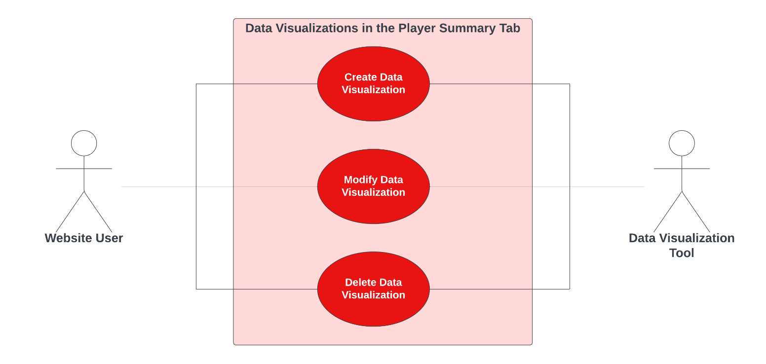

**Use Case Diagram Narrative**

Users can utilize the data visualization tool in the ‘Player Summary’ tab by either creating new data visualizations or modifying or deleting pre-existing ones based on their data needs. This tool exists within the website and will be accessible to all website users via the ‘Player Summary’ tab.

## **Use Case 12 – 15: Game & Career Statistics Tab**

### **Use Case Description: Use Case 12: Upload Data in the Game Statistics tab**

|  |  |  |
| --- | --- | --- |
| **Use Case Name**: Upload Data in the Game Statistics Tab | **ID**: 12 | **Importance Level**: High |
| **Primary Actor**: Administrator | | **Use Case Type**: Detail, Essential |
| **Stakeholders and Interests**:   * Administrators: want to upload data to the statistics tab * Website: the tool used to hold the data | | |
| **Brief Description**: Administrator can upload data in the game statistic tab | | |
| **Trigger**: Administrator navigates to the game statistics tab on the website  **Type**: Internal | | |
| **Relationships**:  Association: Administrator, Website  Include: Modify/Delete/View Data in the game statistics tab  Extend:  Generalization: | | |
| **Normal Flow of Events:**   1. The administrator navigates to the game statistics tab. 2. The administrator imports the data. 3. The administrator clicks *Upload Data.* | | |
| **SubFlows:**   * *None Identified* | | |
| **Alternate/Exceptional Flows:**        3a. The administrator can click the *Save* button to save the data and edit later*.*        3b. The administrator can click the *Cancel* option ad return to the home page | | |

### **Use Case Description: Use Case 13: Modify Data in the Game Statistics tab**

|  |  |  |
| --- | --- | --- |
| **Use Case Name**: Modify Data in the Game Statistics Tab | **ID**: 13 | **Importance Level**: High |
| **Primary Actor**: Administrator | | **Use Case Type**: Detail, Essential |
| **Stakeholders and Interests**:   * Administrators: make necessary changes to the data on the game statistics tab * Website: the tool used to edit the applications * Potential User: may need to make changes to the data added | | |
| **Brief Description**: Administrator can modify data in the game statistic tab | | |
| **Trigger**: Administrators can modify the data in the game statistics tab  **Type**: External | | |
| **Relationships**:  *Association:* Create/Delete/View Data in the game statistics tab  *Include:* Delete data in the game statistics tab  *Extend:*  *Generalization:* | | |
| **Normal Flow of Events:**   1. The administrator navigates to the to the game statistics tab 2. The administrator presses *Modify Data* button opening the data modify window. 3. The administrator edits the data. 4. The administrator presses *Save Changes*. 5. The data is updated in the game statistics tab. | | |
| **SubFlows:**   * *None Identified* | | |
| **Alternate/Exceptional Flows:**  4a. The administrator selects the *Cancel Changes* and is returned to the game statistics tab. | | |

### **Use Case Description: Use Case 14: Delete Data in the Game Statistics tab**

|  |  |  |
| --- | --- | --- |
| **Use Case Name**: Delete Data in the Game Statistics Tab | **ID**: 14 | **Importance Level**: High |
| **Primary Actor**: Administrator | | **Use Case Type**: Detail, Essential |
| **Stakeholders and Interests**:   * Administrator: uses the system to delete unneeded data * Website: tool used to hold data when needed | | |
| **Brief Description**: Administrator can delete data in the game statistics tab | | |
| **Trigger**: Administrator wants to delete private data.  **Type**: External | | |
| **Relationships**:  *Association:* Create/Modify/View data in the game statistics tab  *Include:*  *Extend:* Edit data information  *Generalization:* | | |
| **Normal Flow of Events:**   1. The administrator navigates to the game statistics tab. 2. The administrator presses *Edit Data* to open the editing window. 3. The administrator presses *Delete Data.* 4. The new window displays a dialog box with the message “Are you sure you want to remove the data from the website?” 5. The administrator presses *Yes.* 6. The data is deleted from the website. | | |
| **SubFlows:**   * *None Identified* | | |
| **Alternate/Exceptional Flows:**  5a. The administrator selects *No* and is taken back to the editing window. | | |

### **Use Case Description: Use Case 15: View Information in the Game Statistics tab**

|  |  |  |
| --- | --- | --- |
| **Use Case Name**: View information in the Game Statistics tab | **ID**: 15 | **Importance Level**: |
| **Primary Actor**: Website User | | **Use Case Type**: Detail, Essential |
| **Stakeholders and Interests**:   * Administrator: viewing the data to see if it is correct * Website: holds the data | | |
| **Brief Description**: User can view information in the game statistics tab | | |
| **Trigger**: The administrator views the data  **Type**: Internal | | |
| **Relationships**:  Association: Create/Modify/Delete Data in the game statistics tab  Include:  Extend:  Generalization: | | |
| **Normal Flow of Events:**   1. The administrator clicks on *game statistics tab* to view the data. | | |
| **SubFlows:**   * *None Identified* | | |
| **Alternate/Exceptional Flows:**  1a. the administrator click *Edit Button* if data is incorrect. | | |

### **Use Case 12 – 15: Sequence Diagram**

### **Use Case 12 – 15: Use Case Diagram & Narrative**

**Use Case Diagram Narrative**

The administrator will be able to utilize the data by being able to upload, view, modify and delete in the ‘Game/Career Statistics Tab’. On the other hand, the potential staff member using the website will only have the options to upload and view the data to the ‘Game/Career Statistics Tab’.

## **Use Case 16 - 19: Strength Training Tab**

### **Use Case Description: Use Case 16: Edit a Player’s Workout History from the Strength Training Tab:**

|  |  |  |
| --- | --- | --- |
| **Use Case Name**: Edit a Player’s Workout History from the Strength Training Tab | **ID**: 16 | **Importance Level**: High |
| **Primary Actor**: Administrator | | **Use Case Type**: Detail, Essential |
| **Stakeholders and Interests**:   * Administrator: wants to edit data about a players workout history * Website: where the data is stored that is going to be edited | | |
| **Brief Description**: Admin can edit information about an individual’s workout history in the Strength Training Tab | | |
| **Trigger**: Administrator clicks *Edit Data*  **Type**: External | | |
| **Relationships**:  *Association:* Administrator  *Include:*  *Extend:* Format a Player’s Workout History in Strength Training Tab, Delete a Player’s Workout History in Strength Training Tab  *Generalization:* Workout History in the Strength Training Tab | | |
| **Normal Flow of Events:**   1. The administrator logs onto database. 2. The administrator verifies their identity via two-factor authentication application. 3. The administrator chooses ‘Player’ on sidebar to enable the ‘Player Dashboard’. 4. The administrator clicks the ‘Strength Training’ tab on website’s navigation bar. 5. The administrator clicks the name of the player he wants to edit. 6. The administrator clicks the ‘Edit Data’ button. 7. Administrator edits data. | | |
| **SubFlows:**   * *None Identified* | | |
| **Alternate/Exceptional Flows:**  1a. User is unable to login due to lack of credentials.  2a. User’s authentication is rejected and is unable to access.  3a. User is unable to access ‘Player Dashboard’ due to limited access.  4a. User is unable to access ‘Strength Training’ tab due to limited access.  5a. Entered data parameters are invalid and creation request is rejected. | | |

### **Use Case Description: Use Case 17: Format a Player’s Workout History from the Strength Training Tab:**

|  |  |  |
| --- | --- | --- |
| **Use Case Name**: Format a Player’s Workout History from the Strength Training Tab | **ID**: 17 | **Importance Level**: Low |
| **Primary Actor**: Website User | | **Use Case Type**: Detail, Essential |
| **Stakeholders and Interests**:   * Website User: wants to format data about a players workout history * Website: where the data is stored that is going to be formatted | | |
| **Brief Description**: Admin can format information about an individual's workout history in the Strength Training Tab | | |
| **Trigger**: Website User selects the strength training tab  **Type**: Internal | | |
| **Relationships**:  *Association:* Website User  *Include:*  *Extend:* Edit a Player’s Workout History in Strength Training Tab, Delete a Player’s Workout History in Strength Training Tab  *Generalization:* Workout History in the Strength Training Tab | | |
| **Normal Flow of Events:**   1. The website user logs onto database. 2. The website user verifies their identity via two-factor authentication application. 3. The website user chooses ‘Player’ on sidebar to enable the ‘Player Dashboard’. 4. The website user clicks the ‘Strength Training’ tab on website’s navigation bar. 5. The website user clicks the name of the player he wants to edit. 6. The website user clicks the ‘Edit Data’ button. 7. Website user formats data. | | |
| **SubFlows:**   * *None Identified* | | |
| **Alternate/Exceptional Flows:**  1a. User is unable to login due to lack of credentials.  2a. User’s authentication is rejected and is unable to access.  3a. User is unable to access ‘Player Dashboard’ due to limited access.  4a. User is unable to access ‘Strength Training’ tab due to limited access.  5a. Entered data parameters are invalid and creation request is rejected. | | |

### **Use Case Description: Use Case 18: Delete a Player’s Workout History from the Strength Training Tab:**

|  |  |  |
| --- | --- | --- |
| **Use Case Name**: Delete a Player’s Workout History from the Strength Training Tab | **ID**: 18 | **Importance Level**: High |
| **Primary Actor**: Administrator | | **Use Case Type**: Detail, Essential |
| **Stakeholders and Interests**:   * Administrator: wants to delete data about a players workout history * Website: where the data is stored that is going to be formatted | | |
| **Brief Description**: Admin can delete information about an individual’s workout history with the team | | |
| **Trigger**: Administrator presses *Delete Data*  **Type**: External | | |
| **Relationships**:  *Association:* Administrator  *Include:*  *Extend:* Edit a Player’s Workout History in Strength Training Tab, Format a Player’s Workout History in Strength Training Tab  *Generalization:* Workout History in the Strength Training Tab | | |
| **Normal Flow of Events:**  1. The administrator navigates to the strength training tab  2. The administrator presses *Edit Data* to open the editing window.  3. The administrator presses *Delete Data.*  4. The new window displays a dialog box with the message “Are you sure you want to remove the data from the website?”  5. The administrator presses *Yes.*  6. The data is deleted from the website. | | |
| **SubFlows:**   * *None Identified* | | |
| **Alternate/Exceptional Flows:**        5a. The administrator clicks *No* if they change their mind about deletion | | |

### **Use Case Description: Use Case 19: View Information in the Strength Training Tab:**

|  |  |  |
| --- | --- | --- |
| **Use Case Name**: View Information in the Strength Training Tab | **ID**: 19 | **Importance Level**: Low |
| **Primary Actor**: Website User | | **Use Case Type**: Detail, Essential |
| **Stakeholders and Interests**:   * Administrator: viewing the data to see if it is correct * Website: holds the data | | |
| **Brief Description**: User can view information in the Strength Training Tab | | |
| **Trigger**: The administrator views the data  **Type**: Internal | | |
| **Relationships**:  *Association:* Create/Modify/Delete information in the Strength Training Tab  *Include:*  *Extend:*  *Generalization:* | | |
| **Normal Flow of Events:**   1. The website user navigates to the strength training tab. 2. The website user views the data | | |
| **SubFlows:**   * *None Identified* | | |
| **Alternate/Exceptional Flows:**  2a. the administrator click *Edit* if data is incorrect. | | |

### **Use Case 16 – 19: Sequence Diagram**

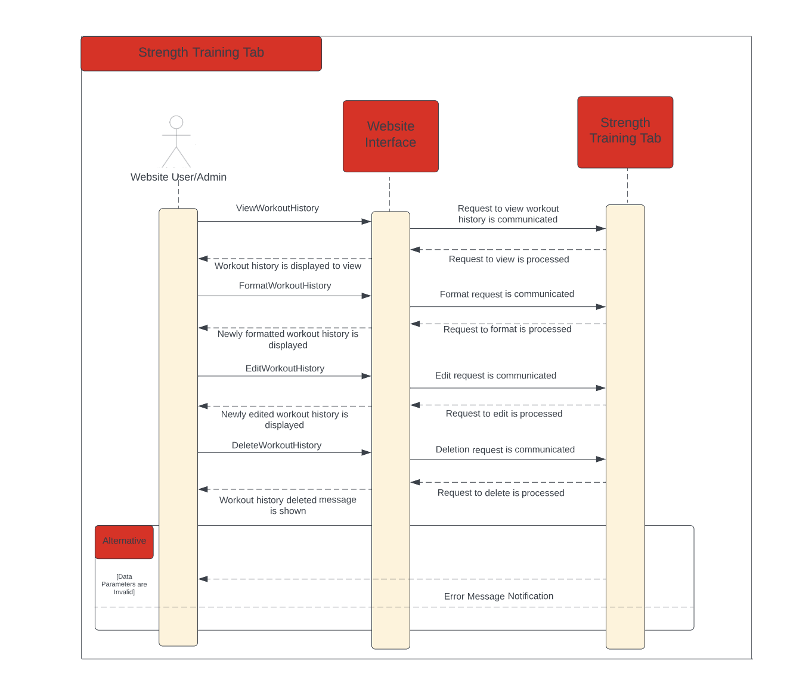

### **Use Case 16 – 19: Use Case Diagram & Narrative**

**Use Case Diagram Narrative**

Users and administrators will utilize the website interface to do several different activities related to workout history in the Strength Training Tab. Users will have permission to view information located in the tab, as well as format a specific player’s workout history. In addition to everything a user can do, administrators will also be able to edit a player’s workout history when changes are needed and delete a player’s workout history when it is no longer relevant.

## **Use Case 20 – 22: Data Visualizations in the Strength Training Tab**

### **Use Case Description: Use Case 20: Create a Data Visualization in the Strength Training Tab**

|  |  |  |
| --- | --- | --- |
| **Use Case Name**: Create a Data Visualization in Strength Training Tab | **ID**: 20 | **Importance Level**: Low |
| **Primary Actor**: Website User | | **Use Case Type**: Detail, Essential |
| **Stakeholders and Interests**:   * Website User: wants to create a data visualization based on data available in selected tab. * Website: tool used collect parameters for data for visualization. * Data Visualization Tool: tool used to build a customized visualization of available data based on user’s needs. | | |
| **Brief Description**: This use case describes how a user can create a customized data visualization based on information in this tab. | | |
| **Trigger**: User clicks on ‘Create New Data Visualization’ button on ‘Strength Training’ tab.  **Type**: External | | |
| **Relationships**:  Association: Website User  Include:  Extend: Modify a Data Visualization in ‘Strength Training’ tab  Generalization: Data Visualizations in the ‘Strength Training’ tab | | |
| **Normal Flow of Events:**   1. The website user logs onto database. 2. The website user verifies their identity via two-factor authentication application. 3. The website user chooses ‘Player’ on sidebar to enable the ‘Player Dashboard’.  * *Executes use-case* (01) *to switch dashboard view to player view.*  1. The website user clicks the ‘Strength Training’ tab on website’s navigation bar. 2. The website user clicks the ‘Create New Visualization’ button on page.  * *Executes use-case* (20) *to create new data visualization*  1. The website user enters data parameters needed for visualization. 2. The website user is presented with data visualization. | | |
| **SubFlows:**   * *None Identified* | | |
| **Alternate/Exceptional Flows:**  1a. User is unable to login due to lack of credentials.  2a. User’s authentication is rejected and is unable to access website.  3a. User is unable to access ‘Player Dashboard’ due to limited access.  4a. User is unable to access ‘Strength Training’ tab due to limited access.  6a. Entered data parameters are invalid and creation request is rejected. | | |

### **Use Case Description: Use Case 21: Modify a Data Visualization in the Strength Training Tab**

|  |  |  |
| --- | --- | --- |
| **Use Case Name**: Modify a Data Visualization in Strength Training Tab | **ID**: 21 | **Importance Level**: Low |
| **Primary Actor**: Website User | | **Use Case Type**: Detail, Essential |
| **Stakeholders and Interests**:   * Website User: wants to modify an existing data visualization based on data available in selected tab. * Website: tool used collect parameters for data for visualization. * Data Visualization Tool: tool used to build a customized visualization of available data based on user’s needs. | | |
| **Brief Description**: This use case describes how a user can modify an already created data visualization based on information in this tab. | | |
| **Trigger**: User clicks on ‘Modify Data Visualization’ button on ‘Strength Training’ tab.  **Type**: External | | |
| **Relationships**:  Association: Website User  Include: Create a Data Visualization in ‘Strength Training’ tab  Extend: Delete a Data Visualization in ‘Strength Training’ tab  Generalization: Data Visualizations in the ‘Strength Training’ tab | | |
| **Normal Flow of Events:**   1. The website user logs onto database. 2. The website user verifies their identity via two-factor authentication. 3. The website user chooses ‘Player’ on sidebar to enable the ‘Player Dashboard’.  * *Executes use-case* (01) *to switch dashboard view to player view.*  1. The website user clicks the ‘Strength Training’ tab on website’s navigation bar. 2. The website user clicks the ‘Create New Visualization’ button on page.  * *Executes use-case* (20) *to create new data visualization*  1. The website user enters data parameters needed for visualization. 2. The website user is presented with data visualization. 3. The website user clicks ‘Modify Data Visualization’ button on selected tab.  * *Executes use-case* (21) *to modify new data visualization* | | |
| **SubFlows:**   * *None Identified* | | |
| **Alternate/Exceptional Flows:**  1a. User is unable to login due to lack of credentials.  2a. User’s authentication is rejected and is unable to access.  3a. User is unable to access ‘Player Dashboard’ due to limited access.  4a. User is unable to access ‘Strength Training’ tab due to limited access.  6a. Entered data parameters are invalid and creation request is rejected.  7a. Entered data parameters are invalid and modification request is rejected. | | |

### **Use Case Description: Use Case 22: Delete a Data Visualization in the Strength Training Tab**

|  |  |  |
| --- | --- | --- |
| **Use Case Name**: Delete Existing Data Visualization in Player Summary Tab | **ID**: 22 | **Importance Level**: Low |
| **Primary Actor**: Website User | | **Use Case Type**: Detail, Essential |
| **Stakeholders and Interests**:   * Website User: wants to modify an existing data visualization based on data available in selected tab. * Website: tool used collect parameters for data for visualization. * Data Visualization Tool: tool used to build a customized visualization of available data based on user’s needs. | | |
| **Brief Description**: This use case describes how a user can delete an already created data visualization based on information in this tab. | | |
| **Trigger**: User clicks on ‘Delete Data Visualization’ button on ‘Strength Training’ tab.  **Type**: External | | |
| **Relationships**:  Association: Website User  Include: Create a Data Visualization in ‘Strength Training’ tab  Extend:  Generalization: Data Visualizations in the ‘Strength Training’ tab | | |
| **Normal Flow of Events:**   1. The website user logs onto database. 2. The website user verifies their identity via two-factor authentication. 3. The website user chooses ‘Player’ on sidebar to enable the ‘Player Dashboard’. 4. *Executes use-case* (01) *to switch dashboard view to player view.* 5. The website user clicks the ‘Strength Training’ tab on website’s navigation bar. 6. The website user clicks the ‘Create New Visualization’ button on page. 7. *Executes use-case* (20) *to create new data visualization* 8. The website user enters data parameters needed for visualization. 9. The website user is presented with data visualization. 10. The website user can delete existing data visualization via the ‘Delete Data Visualization’ button. 11. *Executes use-case* (22) *to delete new data visualization* | | |
| **SubFlows:**   * *None Identified* | | |
| **Alternate/Exceptional Flows:**  1a. User is unable to login due to lack of credentials.  2a. User’s authentication is rejected and is unable to access.  3a. User is unable to access ‘Player Dashboard’ due to limited access.  4a. User is unable to access ‘Strength Training’ tab due to limited access.  6a. Entered data parameters are invalid and creation request is rejected. | | |

### **Use Case 20 – 21: Sequence Diagram**

### **Use Case 20 – 22: Use Case Diagram & Narrative**

**Use Case Diagram Narrative**

Users can utilize the data visualization tool in the Strength Training tab by either creating new data visualizations or modifying or deleting pre-existing ones based on their data needs. This tool exists within the website and will be accessible to all website users via the Strength Training tab.

## **Use Case 23 – 25: Information in the Medical Tab**

### **Use Case Description: Use Case 23: Upload a Player’s Medical Information in the Medical Tab**

|  |  |  |
| --- | --- | --- |
| **Use Case Name**: Upload a Player’s Medical Information in Medical Tab | **ID**: 23 | **Importance Level**: High |
| **Primary Actor**: Administrator | | **Use Case Type**: Essential, Detail |
| **Stakeholders and Interests**:   * Website user: Wants to create and upload a players medical data * Website: tool used to collect parameters for medical data * Medical Page: Page used to display medical record for a player | | |
| **Brief Description**: This used case entails how an Admin can create a medical record for a player on the tab. | | |
| **Trigger**: User clicks on a button in ‘Medical Tab’  **Type**: External | | |
| **Relationships**:  Association: Administrator  Include:  Extend: Modify a Medical Entry in ‘Medical’ Tab  Generalization:  Medical Records in the ‘Medical’ | | |
| **Normal Flow of Events:**   1. Admin logs into Database. 2. Admin verifies identity with two-factor authentication. 3. Admin navigates to Medical Tab    * Executes use case (23) switching from Dashboard to Medical Tab 4. Admin clicks the ‘Create New Medical Record’ Button on page 5. Admin enters medical parameters needed for a recorded player 6. Admins and select user will be presented with medical information on given player | | |
| **SubFlows:**   * *None Identified* | | |
| **Alternate/Exceptional Flows:**  1a. Admin is unable to login due to lack of credentials.  2a. Admin authentication is rejected and unable to access data.  3a. Admin is unable to access ‘Medical tab’ due to limited access.  5a. Entered data is invalid and creation is rejected. | | |

### **Use Case Description: Use Case 24: Edit a Player’s Medical Information in the Medical Tab:**

|  |  |  |
| --- | --- | --- |
| **Use Case Name**: Edit a Player’s Medical Information Tab | **ID**: 24 | **Importance Level**: High |
| **Primary Actor**: Administrator | | **Use Case Type**: Essential, Detail |
| **Stakeholders and Interests**:   * Website user: Wants to edit and upload a player’s medical data * Website: tool used to collect parameters for medical data * Medical Page: Page used to display medical record for a player | | |
| **Brief Description**: This use case entails how an Admin can edit a medical record for a player on the tab. | | |
| **Trigger**: User clicks on a button in ‘Medical Tab’  **Type**: External | | |
| **Relationships**:  Association: Administrator  Include:  Extend: Create/Delete a Medical entry in ‘Medical’ Tab  Generalization:  Medical Records in the ‘Medical’ Tab | | |
| **Normal Flow of Events:**   1. Admin logs into Database. 2. Admin verifies identity with two-factor authentication. 3. Admin navigates to Medical Tab    * Executes use case (24) switching from Dashboard to Medical Tab 4. Admin clicks the ‘Edit Medical Record’ Button on page 5. Admin enters medical parameters needed for a recorded player 6. Admins and select user will be presented with medical information on given player | | |
| **SubFlows:**   * *None Identified* | | |
| **Alternate/Exceptional Flows:**  1a. Admin is unable to login due to lack of credentials.  2a. Admin authentication is rejected and unable to access data.  3a. Admin is unable to access ‘Medical tab’ due to limited access.  5a. Entered data is invalid and creation is rejected. | | |

### **Use Case Description: Use Case 25: Delete a Player’s Medical Information in the Medical Tab:**

|  |  |  |
| --- | --- | --- |
| **Use Case Name**: Delete a Player’s Medical Information Tab | **ID**: 25 | **Importance Level**: High |
| **Primary Actor**: Administrator | | **Use Case Type**: Essential, Detail |
| **Stakeholders and Interests**:   * Website user: Wants to delete and upload a player’s medical data * Website: tool used to collect parameters for medical data * Medical Page: Page used to display medical record for a player | | |
| **Brief Description**: This used case entails how an Admin can delete a medical record for a player on the tab. | | |
| **Trigger**: User clicks on a button in ‘Medical Tab’  **Type**: External | | |
| **Relationships**:  *Association: Administrator*  *Include: Create a Medical Entry in ‘Medical’ Tab*  *Extend: Modify a Medical Entry in ‘Medical’ Tab*  *Generalization:* Medical Records in the ‘Medical’ Tab | | |
| **Normal Flow of Events:**   1. Admin logs into Database. 2. Admin verifies identity with two-factor authentication. 3. Admin navigates to Medical Tab    * Executes use case (26) switching from Dashboard to Medical Tab 4. Admin clicks the ‘Edit New Medical Record’ Button on page 5. Admin enters necessary changes in medical parameters needed for a recorded player 6. Admins and select user will be presented with medical information on given player 7. Admin can delete existing Medical Record    * Executes use case (25) to delete a Medical Record | | |
| **SubFlows:**   * *None Identified* | | |
| **Alternate/Exceptional Flows:**  1a. Admin is unable to login due to lack of credentials.  2a. Admin authentication is rejected and unable to access data.  3a. Admin is unable to access ‘Medical tab’ due to limited access.  5a. Entered data is invalid and creation is rejected.  7a. Deleted data parameters are invalid and deletion request is rejected. | | |

### **Use Case 23 – 25: Sequence Diagram**

### **Use Case 23 – 25: Use Case Diagram & Narrative**

**Use Case Diagram**

**Use Case Diagram Narrative**

Users can view their medical records, which will be displayed via the Website interface. The players' records will be made from data received from the Record form. The Records will show an extensive information regarding a current players conditions and history. This will allow coaches to stay informed on a given player's health and adjust workouts according to a given record. It will also allow coaches to edit, create, and delete specific records throughout the year.

## **Use Case 26 – 28: Medical Status in the Medical Tab**

### **Use Case Description: Use Case 26: Create a Player’s Medical Status in the Medical Tab**

|  |  |  |
| --- | --- | --- |
| **Use Case Name**: Create a Player’s Medical Status Tab | **ID**: 25 | **Importance Level**: High |
| **Primary Actor**: Administrator | | **Use Case Type**: Essential, Detail |
| **Stakeholders and Interests**:   * Website user: Wants to Create and upload a player’s medical status * Website: tool used to collect parameters for medical status * Medical Page: Page used to display medical records and status for a player | | |
| **Brief Description**: This used case entails how an Admin can create a status for a player’s health on the medical tab. | | |
| **Trigger**: User clicks on a button in ‘Medical Tab’  **Type**: External | | |
| **Relationships**:  *Association: Administrator*  *Include: Create a Medical Status in ‘Medical’ Tab*  *Extend:*  *Generalization:* Medical Records in the ‘Medical’ Tab | | |
| **Normal Flow of Events:**   1. Admin logs into Database. 2. Admin verifies identity with two-factor authentication. 3. Admin navigates to Medical Tab    * Executes use case (23) switching from Dashboard to Medical Tab 4. Admin clicks the ‘Create New Medical Status’ Button on page    * Executes use case (26) to create new status 5. Admin enters necessary changes in medical parameters needed for a recorded player 6. Admins and select user will be presented with medical status on a given player | | |
| **SubFlows:**   * *None Identified* | | |
| **Alternate/Exceptional Flows:**  1a. Admin is unable to login due to lack of credentials.  2a. Admin authentication is rejected and unable to access data.  3a. Admin is unable to access ‘Medical tab’ due to limited access.  5a. Entered data is invalid and creation is rejected. | | |

### **Use Case Description: Use Case 27: Edit a Player’s Medical Status in the Medical Tab**

|  |  |  |
| --- | --- | --- |
| **Use Case Name**: Edit a Player’s Medical Status Tab | **ID**: 27 | **Importance Level**: High |
| **Primary Actor**: Administrator | | **Use Case Type**: Essential, Detail |
| **Stakeholders and Interests**:   * Website user: Wants to update and upload a player’s medical status * Website: tool used to collect parameters for medical status * Medical Page: Page used to display medical records and status for a player | | |
| **Brief Description**: This used case entails how an Admin can update a status for a player’s health on the medical tab. | | |
| **Trigger**: User clicks on a button in ‘Medical Tab’  **Type**: External | | |
| **Relationships**:  *Association: Administrator*  *Include: Update a Medical Status in ‘Medical’ Tab*  *Extend: Create a Medical Status in ‘Medical’ Tab*  *Generalization:* Medical Records in the ‘Medical’ Tab | | |
| **Normal Flow of Events:**   1. Admin logs into Database. 2. Admin verifies identity with two-factor authentication. 3. Admin navigates to Medical Tab    * Executes use case (23) switching from Dashboard to Medical Tab 4. Admin clicks the ‘Create New Medical Status’ Button on page    * Executes use case (26) to create new status 5. Admin clicks the ‘Update Medical status’ button on page 6. Admin enters necessary changes in medical parameters needed for a recorded player 7. Admins and select user will be presented with medical status on a given player | | |
| **SubFlows:**   * *None Identified* | | |
| **Alternate/Exceptional Flows:**  1a. Admin is unable to login due to lack of credentials.  2a. Admin authentication is rejected and unable to access data.  3a. Admin is unable to access ‘Medical tab’ due to limited access.  4a. Admin is unable to access ‘Medical Status’ due to limited access.  6a. Entered data is invalid and creation is rejected.  7a. Admin is unable to access ‘Medical Status’ due to limited access. | | |

### **Use Case Description: Use Case 28: Delete a Player’s Medical Status in the Medical Tab**

|  |  |  |
| --- | --- | --- |
| **Use Case Name**: Delete a Player’s Medical Status Tab | **ID**: 28 | **Importance Level**: High |
| **Primary Actor**: Administrator | | **Use Case Type**: Essential, Detail |
| **Stakeholders and Interests**:   * Website user: Wants to delete and upload a player’s medical status * Website: tool used to collect parameters for medical status * Medical Page: Page used to display medical records and status for a player | | |
| **Brief Description**: This used case entails how an Admin can delete status for a player’s health on the medical tab. | | |
| **Trigger**: User clicks on a button in ‘Medical Tab’  **Type**: External | | |
| **Relationships**:  *Association: Administrator*  *Include: Delete a Medical Status in ‘Medical’ Tab*  *Extend: Update a Medical Status in ‘Medical’ Tab*  *Create a Medical Status in ‘Medical’ Tab*  *Generalization:* Medical Records in the ‘Medical’ Tab | | |
| **Normal Flow of Events:**   1. Admin logs into Database. 2. Admin verifies identity with two-factor authentication. 3. Admin navigates to Medical Tab    * Executes use case (23) switching from Dashboard to Medical Tab 4. Admin clicks the ‘Create New Medical Status’ Button on page    * Executes use case (26) to create new status 5. Admin clicks the ‘Delete Medical status’ button on page 6. Admin enters necessary changes in medical parameters needed for a recorded player 7. Admins and select user will be presented with medical status on a given player | | |
| **SubFlows:**   * *None Identified* | | |
| **Alternate/Exceptional Flows:**  1a. Admin is unable to login due to lack of credentials.  2a. Admin authentication is rejected and unable to access data.  3a. Admin is unable to access ‘Medical tab’ due to limited access.  4a. Admin is unable to access ‘Medical Status’ due to limited access.  6a. Entered data is invalid and creation is rejected.  7a. Admin is unable to access ‘Medical Status’ due to limited access. | | |

### **Use Case 26 – 28: Sequence Diagram**

### **Use Case 26 – 28: Use Case Diagram & Narrative**

**Use Case Diagram**

**Use Case Diagram Narrative**

Users can view their medical status, which will be displayed via the Website interface in the medical tab. The player's status will be made from data received from the Record form and a status ping. The status will show the current players condition to play. This will allow coaches to stay informed on a given players' health whether they are Injured, healthy, or out of play. With the provided status, coaches can then adjust team composition and practice plans based on their condition. It will also allow coaches to edit, create, and delete specific statuses throughout the year.

## **Use Case 29: View Information in the Medical Tab**

### **Use Case Description: Use Case 29: View Information in the Medical Tab**

|  |  |  |
| --- | --- | --- |
| **Use Case Name**: View Information in the Medical Tab | **ID**: 29 | **Importance Level**: Low |
| **Primary Actor**: Administrator | | **Use Case Type**: Detail, Essential |
| **Stakeholders and Interests**:   * Administrator: viewing the data to see if the information is correct * Website: holds the data | | |
| **Brief Description**: User can view information in the Medical Tab | | |
| **Trigger**: the administrator views the data  **Type**: Internal | | |
| **Relationships**:  Association: Create/Modify/Delete information in the Medical Tab  Include:  Extend:  Generalization: | | |
| **Normal Flow of Events:**   1. The administrator clicks *Medical Tab* to view the data | | |
| **SubFlows:**   * *None Identified* | | |
| **Alternate/Exceptional Flows:**  1a. the administrator click *Edit* if data is incorrect | | |

### **Use Case 29: Sequence Diagram**

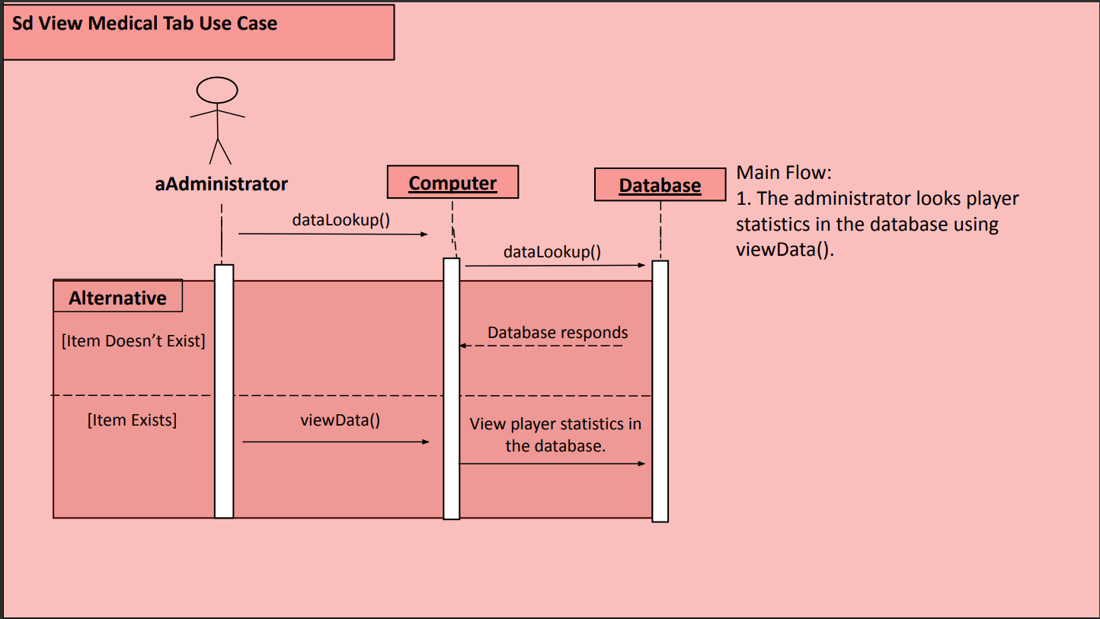

### **Use Case 29: Use Case Diagram & Narrative:**

**Use Case Diagram Narrative**

Users can view their medical status, which will be displayed via the Website interface in the medical tab. The player's status will be made from data received from the Record form and a status ping. The status will show the player's current condition of playing. This will allow coaches to stay informed on a given players' health whether they are Injured, healthy, or out of play. With the provided status, coaches can then adjust team composition and practice plans based on their condition. It will also allow coaches to modify or view specific statuses throughout the year.

## **Use Case 30 – 32: Data Visualizations in the Medical Tab**

### **Use Case Description: Use Case 30: Create a Data Visualization in the Medical Tab**

|  |  |  |
| --- | --- | --- |
| **Use Case Name**: Create a Data Visualization in Medical Tab | **ID**: 30 | **Importance Level**: Low |
| **Primary Actor**: Website User | | **Use Case Type**: Detail, Essential |
| **Stakeholders and Interests**:   * Website User: wants to create a data visualization based on data available in selected tab. * Website: tool used collect parameters for data for visualization. * Data Visualization Tool: tool used to build a customized visualization of available data based on user’s needs. | | |
| **Brief Description**: This use case describes how a user can create a customized data visualization based on information in this tab. | | |
| **Trigger**: User clicks on ‘Create New Data Visualization’ button on Medical Tab.  **Type**: External | | |
| **Relationships**:  Association: Website User  Include:  Extend: Modify a Data Visualization in Medical Tab  Generalization: Data Visualizations in the Medical Tab | | |
| **Normal Flow of Events:**   1. The website user logs onto database. 2. The website user verifies their identity via two-factor authentication application. 3. The website user chooses ‘Player’ on sidebar to enable the ‘Player Dashboard’.  * *Executes use-case* (01) *to switch dashboard view to player view.*  1. The website user clicks the Medical Tab on website’s navigation bar. 2. The website user clicks the ‘Create New Visualization’ button on page.  * *Executes use-case* (30) *to create new data visualization*  1. The website user enters data parameters needed for visualization. 2. The website user is presented with data visualization. | | |
| **SubFlows:**   * *None Identified* | | |
| **Alternate/Exceptional Flows:**  1a. User is unable to login due to lack of credentials.  2a. User’s authentication is rejected and is unable to access website.  3a. User is unable to access ‘Player Dashboard’ due to limited access.  4a. User is unable to access Medical Tab due to limited access.  6a. Entered data parameters are invalid and creation request is rejected. | | |

### **Use Case Description: Use Case 31: Modify a Data Visualization in the Medical Tab**

|  |  |  |
| --- | --- | --- |
| **Use Case Name**: Modify a Data Visualization in Medical Tab | **ID**: 31 | **Importance Level**: Low |
| **Primary Actor**: Website User | | **Use Case Type**: Detail, Essential |
| **Stakeholders and Interests**:   * Website User: wants to modify an existing data visualization based on data available in selected tab. * Website: tool used collect parameters for data for visualization. * Data Visualization Tool: tool used to build a customized visualization of available data based on user’s needs. | | |
| **Brief Description**: This use case describes how a user can modify an already created data visualization based on information in this tab. | | |
| **Trigger**: User clicks on ‘Modify Data Visualization’ button on Medical Tab.  **Type**: External | | |
| **Relationships**:  Association: Website User  Include: Create a Data Visualization in Medical Tab  Extend: Delete a Data Visualization in Medical Tab  Generalization: Data Visualizations in the Medical Tab | | |
| **Normal Flow of Events:**   1. The website user logs onto database. 2. The website user verifies their identity via two-factor authentication. 3. The website user chooses ‘Player’ on sidebar to enable the ‘Player Dashboard’. 4. *Executes use-case* (01) *to switch dashboard view to player view.* 5. The website user clicks the Medical Tab on website’s navigation bar. 6. The website user clicks the ‘Create New Visualization’ button on page. 7. *Executes use-case* (30) *to create new data visualization* 8. The website user enters data parameters needed for visualization. 9. The website user is presented with data visualization. 10. The website user clicks ‘Modify Data Visualization’ button on selected tab. 11. *Executes use-case* (31) *to modify new data visualization* | | |
| **SubFlows:**   * *None Identified* | | |
| **Alternate/Exceptional Flows:**  1a. User is unable to login due to lack of credentials.  2a. User’s authentication is rejected and is unable to access.  3a. User is unable to access ‘Player Dashboard’ due to limited access.  4a. User is unable to access Medical Tab due to limited access.  6a. Entered data parameters are invalid and creation request is rejected.  7a. Entered data parameters are invalid and modification request is rejected. | | |

### **Use Case Description: Use Case 32: Delete a Data Visualization in the Medical Tab**

|  |  |  |
| --- | --- | --- |
| **Use Case Name**: Delete Existing Data Visualization in Medical Tab | **ID**: 32 | **Importance Level**: Low |
| **Primary Actor**: Website User | | **Use Case Type**: Detail, Essential |
| **Stakeholders and Interests**:   * Website User: wants to modify an existing data visualization based on data available in selected tab. * Website: tool used collect parameters for data for visualization. * Data Visualization Tool: tool used to build a customized visualization of available data based on user’s needs. | | |
| **Brief Description**: This use case describes how a user can delete an already created data visualization based on information in this tab. | | |
| **Trigger**: User clicks on ‘Delete Data Visualization’ button on Medical Tab.  **Type**: External | | |
| **Relationships**:  Association: Website User  Include: Create a Data Visualization in Medical Tab  Extend:  Generalization: Data Visualizations in the Medical Tab | | |
| **Normal Flow of Events:**   1. The website user logs onto database. 2. The website user verifies their identity via two-factor authentication. 3. The website user chooses ‘Player’ on sidebar to enable the ‘Player Dashboard’. 4. *Executes use-case* (01) *to switch dashboard view to player view.* 5. The website user clicks the Medical Tab on website’s navigation bar. 6. The website user clicks the ‘Create New Visualization’ button on page. 7. *Executes use-case* (30) *to create new data visualization* 8. The website user enters data parameters needed for visualization. 9. The website user is presented with data visualization. 10. The website user can delete existing data visualization via the ‘Delete Data Visualization’ button. 11. *Executes use-case* (32) *to delete new data visualization* | | |
| **SubFlows:**   * *None Identified* | | |
| **Alternate/Exceptional Flows:**  1a. User is unable to login due to lack of credentials.  2a. User’s authentication is rejected and is unable to access.  3a. User is unable to access ‘Player Dashboard’ due to limited access.  4a. User is unable to access Medical Tab due to limited access.  6a. Entered data parameters are invalid and creation request is rejected. | | |

### **Use Case 30 –32: Sequence Diagram**

### **Use Case 30 – 32: Use Case Diagram & Narrative**

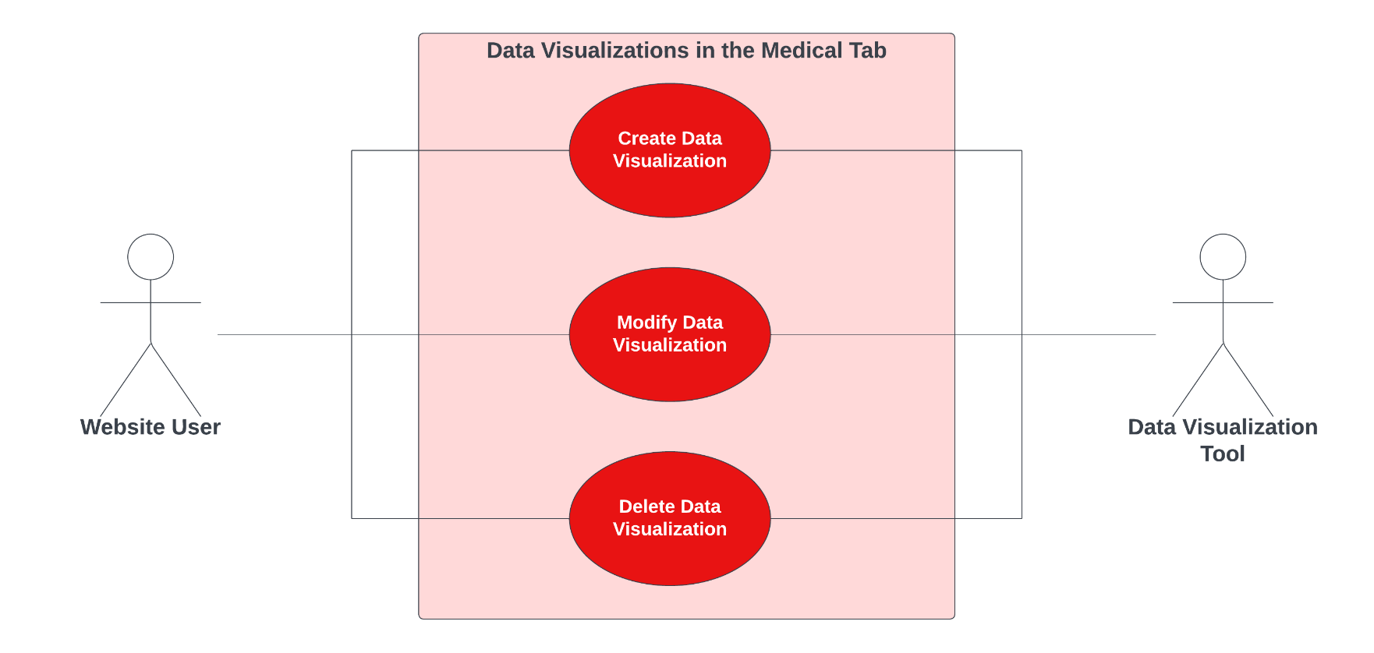

**Use Case Diagram Narrative**

Users can utilize the data visualization tool in the ‘Medical’ tab by either creating new data visualizations or modifying or deleting pre-existing ones based on their data needs. This tool exists within the website and will be accessible to all website users via the ‘Medical’ tab.

## **Use Case 33 – 34: Nutrition Tab**

### **Use Case Description: Use Case 33: Edit Information in the Nutrition Tab**

|  |  |  |
| --- | --- | --- |
| **Use Case Name**:  Edit Information in the Nutrition Tab | **ID**: 33 | **Importance Level**: High |
| **Primary Actor**: Administrator | | **Use Case Type**: Detail, Essential |
| **Stakeholders and Interests**:   * Administrator: wants to edit data about a player’s nutrition * Website: where the data is stored that is going to be edited | | |
| **Brief Description**: Administrator can edit information in the Nutrition Tab | | |
| **Trigger**: User clicks on *Edit Data* in the Nutrition Tab  **Type**: External | | |
| **Relationships**:  *Association:* Administrator  *Include:*  *Extend:*  *Generalization:* Nutrition info in the Nutrition Tab | | |
| **Normal Flow of Events:**   * 1. The administrator navigates to the Nutrition Tab   2. The administrator clicks *Edit Data*   3. The administrator edits the data | | |
| **SubFlows:**   * *None Identified* | | |
| **Alternate/Exceptional Flows:**        3a. Entered data parameters are invalid and creation request is rejected. | | |

### **Use Case 34: View Information in the Nutrition Tab**

|  |  |  |
| --- | --- | --- |
| **Use Case Name**: View Information in the Nutrition Tab | **ID**: 34 | **Importance Level**: Low |
| **Primary Actor**: Administrator | | **Use Case Type**: Detail, Essential |
| **Stakeholders and Interests**:   * Administrator: viewing the data to see if it is correct * Website: holds the data | | |
| **Brief Description**: User can view information in the Medical Tab | | |
| **Trigger**: The administrator views the data  **Type**: Internal | | |
| **Relationships**:  Association: Create/Modify/Delete information in the Nutrition Tab  Include:  Extend:  Generalization: | | |
| **Normal Flow of Events:**   1. The administrator clicks on *Nutrition Tab* to view the data | | |
| **SubFlows:**   * *None Identified* | | |
| **Alternate/Exceptional Flows:**  1a. The Administrator clicks *Edit* if data is incorrect. | | |

### **Use Case 33 – 34: Sequence Diagram**

### **Use Case 33 – 34: Use Case Diagram & Narrative**

**Use Case Diagram Narrative**

There are two different activities we can do related to information in the Nutrition Tab of our prototype. One for each level of access to our database. Administrators will be able to edit information in the nutrition tab if changes are needed, while users will only be able to view the information that is already in the nutrition tab. The website interface will be used for both use cases.

## **Use Case 35 – 37: Data Visualizations in the Nutrition Tab**

### **Use Case Description: Use Case 35: Create a Data Visualization in the Nutrition Tab**

|  |  |  |
| --- | --- | --- |
| **Use Case Name**: Create a Data Visualization in Nutrition Tab | **ID**: 35 | **Importance Level**: Low |
| **Primary Actor**: Website User | | **Use Case Type**: Detail, Essential |
| **Stakeholders and Interests**:   * Website User: wants to create a data visualization based on data available in selected tab. * Website: tool used collect parameters for data for visualization. * Data Visualization Tool: tool used to build a customized visualization of available data based on user’s needs. | | |
| **Brief Description**: This use case describes how a user can create a customized data visualization based on information in this tab. | | |
| **Trigger**: User clicks on ‘Create New Data Visualization’ button on Nutrition Tab.  **Type**: External | | |
| **Relationships**:  *Association:* Website User  *Include:*  *Extend:* Modify a Data Visualization in Nutrition Tab  *Generalization:* Data Visualizations in the Nutrition Tab | | |
| **Normal Flow of Events:**   1. The website user logs onto database. 2. The website user verifies their identity via two-factor authentication application. 3. The website user chooses ‘Player’ on sidebar to enable the ‘Player Dashboard’.    1. *Executes use-case* (01) *to switch dashboard view to player view.* 4. The website user clicks the Nutrition Tab on website’s navigation bar. 5. The website user clicks the ‘Create New Visualization’ button on page.    1. *Executes use-case* (35) *to create new data visualization* 6. The website user enters data parameters needed for visualization. 7. The website user is presented with data visualization. | | |
| **SubFlows:**   * *None Identified* | | |
| **Alternate/Exceptional Flows:**  1a. User is unable to login due to lack of credentials.  2a. User’s authentication is rejected and is unable to access website.  3a. User is unable to access ‘Player Dashboard’ due to limited access.  4a. User is unable to access Nutrition Tab due to limited access.  6a. Entered data parameters are invalid and creation request is rejected. | | |

### **Use Case Description: Use Case 36: Modify a Data Visualization in the Nutrition Tab**

|  |  |  |
| --- | --- | --- |
| **Use Case Name**: Modify a Data Visualization in Nutrition Tab | **ID**: 36 | **Importance Level**: Low |
| **Primary Actor**: Website User | | **Use Case Type**: Detail, Essential |
| **Stakeholders and Interests**:   * Website User: wants to modify an existing data visualization based on data available in selected tab. * Website: tool used collect parameters for data for visualization. * Data Visualization Tool: tool used to build a customized visualization of available data based on user’s needs. | | |
| **Brief Description**: This use case describes how a user can modify an already created data visualization based on information in this tab. | | |
| **Trigger**: User clicks on ‘Modify Data Visualization’ button on Nutrition Tab  **Type**: External | | |
| **Relationships**:  Association: Website User  Include: Create a Data Visualization in Nutrition Tab  Extend: Delete a Data Visualization in Nutrition Tab  Generalization: Data Visualizations in the Nutrition Tab | | |
| **Normal Flow of Events:**   1. The website user logs onto database. 2. The website user verifies their identity via two-factor authentication. 3. The website user chooses ‘Player’ on sidebar to enable the ‘Player Dashboard’.    1. *Executes use-case* (01) *to switch dashboard view to player view.* 4. The website user clicks the Medical Tab on website’s navigation bar. 5. The website user clicks the ‘Create New Visualization’ button on page.    1. *Executes use-case* (35) *to create new data visualization* 6. The website user enters data parameters needed for visualization. 7. The website user is presented with data visualization. 8. The website user clicks ‘Modify Data Visualization’ button on selected tab.    1. *Executes use-case* (36) *to modify new data visualization* | | |
| **SubFlows:**   * *None Identified* | | |
| **Alternate/Exceptional Flows:**  1a. User is unable to login due to lack of credentials.  2a. User’s authentication is rejected and is unable to access.  3a. User is unable to access ‘Player Dashboard’ due to limited access.  4a. User is unable to access Nutrition Tab due to limited access.  6a. Entered data parameters are invalid and creation request is rejected.  7a. Entered data parameters are invalid and modification request is rejected. | | |

### **Use Case Description: Use Case 37: Delete a Data Visualization in the Nutrition Tab**

|  |  |  |
| --- | --- | --- |
| **Use Case Name**: Delete Existing Data Visualization in Nutrition Tab | **ID**: 37 | **Importance Level**: Low |
| **Primary Actor**: Website User | | **Use Case Type**: Detail, Essential |
| **Stakeholders and Interests**:   * Website User: wants to modify an existing data visualization based on data available in selected tab. * Website: tool used collect parameters for data for visualization. * Data Visualization Tool: tool used to build a customized visualization of available data based on user’s needs. | | |
| **Brief Description**: This use case describes how a user can delete an already created data visualization based on information in this tab. | | |
| **Trigger**: User clicks on ‘Delete Data Visualization’ button on Nutrition Tab  **Type**: External | | |
| **Relationships**:  *Association: Website User*  *Include: Create a Data Visualization in Nutrition Tab*  *Extend:*  *Generalization: Data Visualizations in the Nutrition Tab* | | |
| **Normal Flow of Events:**   1. The website user logs onto database. 2. The website user verifies their identity via two-factor authentication. 3. The website user chooses ‘Player’ on sidebar to enable the ‘Player Dashboard’.    1. *Executes use-case* (01) *to switch dashboard view to player view.* 4. The website user clicks the Nutrition Tab on website’s navigation bar. 5. The website user clicks the ‘Create New Visualization’ button on page.    1. *Executes use-case* (35) *to create new data visualization* 6. The website user enters data parameters needed for visualization. 7. The website user is presented with data visualization. 8. The website user can delete existing data visualization via the ‘Delete Data Visualization’ button.    1. *Executes use-case* (37) *to delete new data visualization* | | |
| **SubFlows:**   * *None Identified* | | |
| **Alternate/Exceptional Flows:**  1a. User is unable to login due to lack of credentials.  2a. User’s authentication is rejected and is unable to access.  3a. User is unable to access ‘Player Dashboard’ due to limited access.  4a. User is unable to access Nutrition Tab due to limited access.  6a. Entered data parameters are invalid and creation request is rejected. | | |

### **Use Case 35 – 37: Sequence Diagram**

### **Use Case 35 – 37: Use Case Diagram & Narrative**

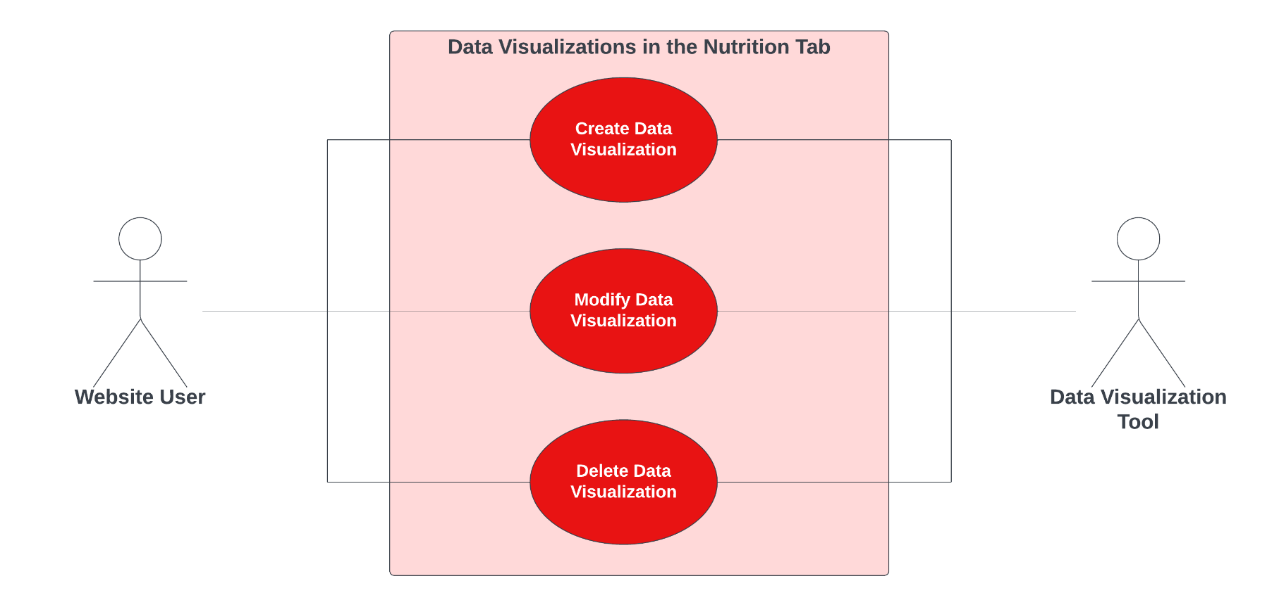

**Use Case Diagram Narrative**

Users can utilize the data visualization tool in the ‘Nutrition’ tab by either creating new data visualizations or modifying or deleting pre-existing ones based on their data needs. This tool exists within the website and will be accessible to all website users via the ‘Nutrition’ tab.

## **Use Case 38 – 39: Practice Data**

### **Use Case Description: Use Case 38: View Information in the Practice Data Tab:**

|  |  |  |
| --- | --- | --- |
| **Use Case Name**: View Information in the Practice Data Tab | **ID**: 38 | **Importance Level**: Low |
| **Primary Actor**: Website User | | **Use Case Type**: Detail, Essential |
| **Stakeholders and Interests**:   * Website User: wants to view information in the Practice Data Tab * Website Interface: tool used to administer changes in the Practice Data Tab | | |
| **Brief Description**: This use case describes how a website user can view information in the Practice Data Tab | | |
| **Trigger**: User clicks ‘view information’ button in the Practice Data Tab  **Type**: External | | |
| **Relationships**:  Association: Website User  Include:  Extend:  Generalization:  Information in the Practice Data Tab | | |
| **Normal Flow of Events:**   1. Website user logs into database. 2. Website user verifies their identity via two-factor authentication. 3. Website user chooses ‘Player’ or ‘Team’ on the sidebar to enable either the Player or Team Dashboard 4. Website user clicks the ‘Practice Data Tab’ on the navigation bar. 5. Website user views desired practice data on the page. | | |
| **SubFlows:**   * *None Identified* | | |
| **Alternate/Exceptional Flows:**  1a. User is unable to login due to lack of credentials.  2a. User’s authentication is rejected and unable to grant access.  3a. User is unable to enable neither Player nor Team Dashboard due to limited access.  4a. User is unable to access Practice Data Tab | | |

### **Use Case Description: Use Case 39: Edit Practice Data within the Practice Data Tab:**

|  |  |  |
| --- | --- | --- |
| **Use Case Name**: Edit Practice Data with the Practice Data Tab | **ID**: 39 | **Importance Level**: High |
| **Primary Actor**: Administrator | | **Use Case Type**: Detail, Essential |
| **Stakeholders and Interests**:   * Administrator: wants to edit practice in the Practice Data Tab * Website Interface: tool used to administer changes in the Player Summary Tab | | |
| **Brief Description**: This use case describes how an administrator can edit practice data within the Practice Data Tab | | |
| **Trigger**: Administrator clicks ‘edit data’ button in the Practice Data Summary Tab  **Type**: External | | |
| **Relationships**:  Association: Administrator, Content Management System  Include:  Extend:  Generalization:  Practice data in the Practice Data Tab | | |
| **Normal Flow of Events:**   1. Website user logs into database. 2. Website user verifies their identity via two-factor authentication. 3. Website user chooses ‘Player’ or ‘Team’ on the sidebar to enable either the Player or Team Dashboard 4. Website user clicks the ‘Practice Data Tab’ on the navigation bar. 5. The administrator clicks on the desired practice data on the page. 6. The administrator clicks ‘Edit Practice Data’ on the right sidebar. 7. The administrator enters changes and clicks ‘save’ | | |
| **SubFlows:**   * *None Identified* | | |
| **Alternate/Exceptional Flows:**   1a. Admin is unable to login due to lack of credentials.  2a. Admin’s authentication is rejected and unable to grant access.  6a. Admin’s edit request is rejected | | |

### **Use Case 38 – 39: Sequence Diagram**

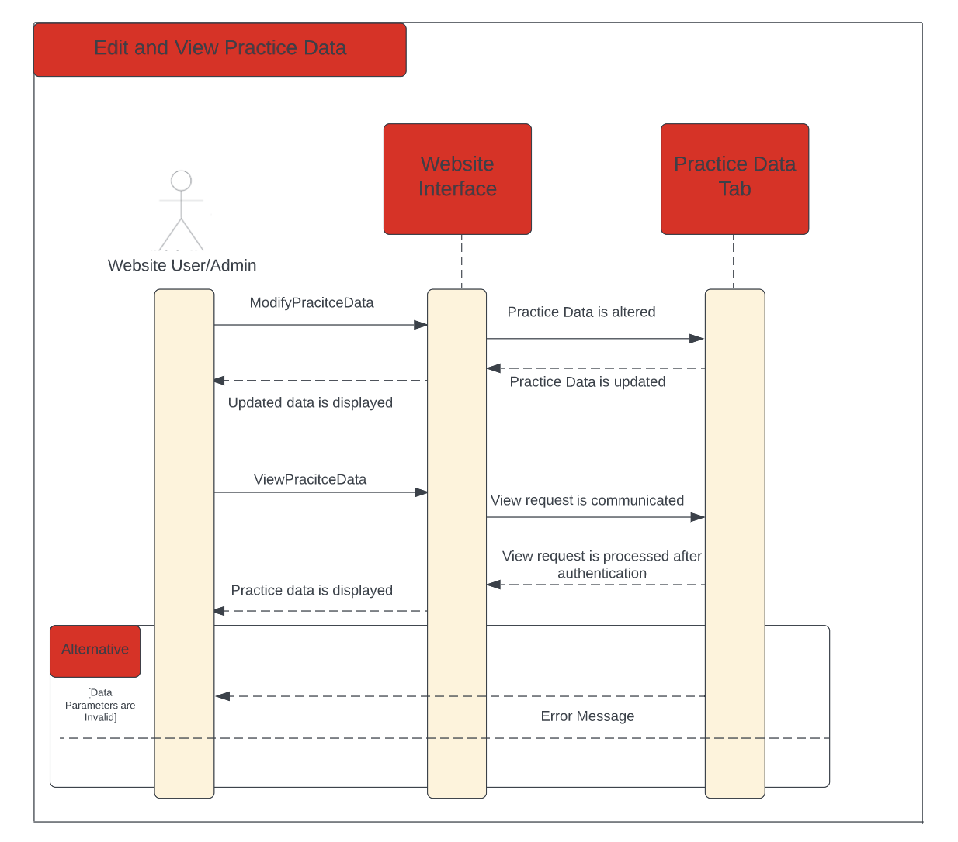

### **Use Case 38 – 39: Use Case Diagram & Narrative**

**Use Case Diagram Narrative**

Website users can interact with the practice tab by viewing information that an admin has edited. This tool allows for players to review and analyze their current stats in practice to improve growth and shine light on weaker areas.

## **Use Case 40 – 43: Data Visualizations in the Practice Data Tab**

### **Use Case Description: Use Case 40: Create a Data Visualization in the Practice Data Tab**

|  |  |  |
| --- | --- | --- |
| **Use Case Name**: Create a Data Visualization in Practice Data Tab | **ID**: 40 | **Importance Level**: Low |
| **Primary Actor**: Website User | | **Use Case Type**: Detail, Essential |
| **Stakeholders and Interests**:   * Website User: wants to create a data visualization based on data available in selected tab. * Website: tool used collect parameters for data for visualization. * Data Visualization Tool: tool used to build a customized visualization of available data based on user’s needs. | | |
| **Brief Description**: This use case describes how a user can create a customized data visualization based on information in this tab. | | |
| **Trigger**: User clicks on ‘Create New Data Visualization’ button on Practice Data Tab.  **Type**: External | | |
| **Relationships**:  *Association:* Website User  *Include:*  *Extend:* Modify a Data Visualization in Nutrition Tab  *Generalization:* Data Visualizations in the Nutrition Tab | | |
| **Normal Flow of Events:**   1. The website user logs onto database. 2. The website user verifies their identity via two-factor authentication application. 3. The website user chooses ‘Player’ on sidebar to enable the ‘Player Dashboard’.    1. *Executes use-case* (01) *to switch dashboard view to player view.* 4. The website user clicks the Practice Data Tab on website’s navigation bar. 5. The website user clicks the ‘Create New Visualization’ button on page.    1. *Executes use-case* (40) *to create new data visualization* 6. The website user enters data parameters needed for visualization. 7. The website user is presented with data visualization. | | |
| **SubFlows:**   * *None Identified* | | |
| **Alternate/Exceptional Flows:**  1a. User is unable to login due to lack of credentials.  2a. User’s authentication is rejected and is unable to access website.  3a. User is unable to access ‘Player Dashboard’ due to limited access.  4a. User is unable to access Practice Data Tab due to limited access.  6a. Entered data parameters are invalid and creation request is rejected. | | |

### **Use Case Description: Use Case 41: Modify a Data Visualization in the Practice Data Tab**

|  |  |  |
| --- | --- | --- |
| **Use Case Name**: Modify a Data Visualization in Practice Data Tab | **ID**: 41 | **Importance Level**: Low |
| **Primary Actor**: Website User | | **Use Case Type**: Detail, Essential |
| **Stakeholders and Interests**:   * Website User: wants to modify an existing data visualization based on data available in selected tab. * Website: tool used collect parameters for data for visualization. * Data Visualization Tool: tool used to build a customized visualization of available data based on user’s needs. | | |
| **Brief Description**: This use case describes how a user can modify an already created data visualization based on information in this tab. | | |
| **Trigger**: User clicks on ‘Modify Data Visualization’ button on Practice Data Tab  **Type**: External | | |
| **Relationships**:  Association: Website User  Include: Create a Data Visualization in Nutrition Tab  Extend: Delete a Data Visualization in Nutrition Tab  Generalization: Data Visualizations in the Nutrition Tab | | |
| **Normal Flow of Events:**   1. The website user logs onto database. 2. The website user verifies their identity via two-factor authentication. 3. The website user chooses ‘Player’ on sidebar to enable the ‘Player Dashboard’.    1. *Executes use-case* (01) *to switch dashboard view to player view.* 4. The website user clicks the Practice Data Tab on website’s navigation bar. 5. The website user clicks the ‘Create New Visualization’ button on page.    1. *Executes use-case* (40) *to create new data visualization* 6. The website user enters data parameters needed for visualization. 7. The website user is presented with data visualization. 8. The website user clicks ‘Modify Data Visualization’ button on selected tab.    1. *Executes use-case* (41) *to modify new data visualization* | | |
| **SubFlows:**   * *None Identified* | | |
| **Alternate/Exceptional Flows:**  1a. User is unable to login due to lack of credentials.  2a. User’s authentication is rejected and is unable to access.  3a. User is unable to access ‘Player Dashboard’ due to limited access.  4a. User is unable to access Practice Data Tab due to limited access.  6a. Entered data parameters are invalid and creation request is rejected.  7a. Entered data parameters are invalid and modification request is rejected. | | |

### **Use Case Description: Use Case 42: Delete a Data Visualization in the Practice Data Tab**

|  |  |  |
| --- | --- | --- |
| **Use Case Name**: Delete Existing Data Visualization in Practice Data Tab | **ID**: 42 | **Importance Level**: Low |
| **Primary Actor**: Website User | | **Use Case Type**: Detail, Essential |
| **Stakeholders and Interests**:   * Website User: wants to modify an existing data visualization based on data available in selected tab. * Website: tool used collect parameters for data for visualization. * Data Visualization Tool: tool used to build a customized visualization of available data based on user’s needs. | | |
| **Brief Description**: This use case describes how a user can delete an already created data visualization based on information in this tab. | | |
| **Trigger**: User clicks on ‘Delete Data Visualization’ button on Practice Data Tab  **Type**: External | | |
| **Relationships**:  *Association: Website User*  *Include: Create a Data Visualization in Nutrition Tab*  *Extend:*  *Generalization: Data Visualizations in the Nutrition Tab* | | |
| **Normal Flow of Events:**   1. The website user logs onto database. 2. The website user verifies their identity via two-factor authentication. 3. The website user chooses ‘Player’ on sidebar to enable the ‘Player Dashboard’.    1. *Executes use-case* (01) *to switch dashboard view to player view.* 4. The website user clicks the Practice Data Tab on website’s navigation bar. 5. The website user clicks the ‘Create New Visualization’ button on page.    1. *Executes use-case* (40) *to create new data visualization* 6. The website user enters data parameters needed for visualization. 7. The website user is presented with data visualization. 8. The website user can delete existing data visualization via the ‘Delete Data Visualization’ button.    1. *Executes use-case* (42) *to delete new data visualization* | | |
| **SubFlows:**   * *None Identified* | | |
| **Alternate/Exceptional Flows:**  1a. User is unable to login due to lack of credentials.  2a. User’s authentication is rejected and is unable to access.  3a. User is unable to access ‘Player Dashboard’ due to limited access.  4a. User is unable to access Practice Tab due to limited access.  6a. Entered data parameters are invalid and creation request is rejected. | | |

### **Use Case 40 – 42: Sequence Diagram**

### **Use Case 40 – 42: Use Case Diagram & Narrative**

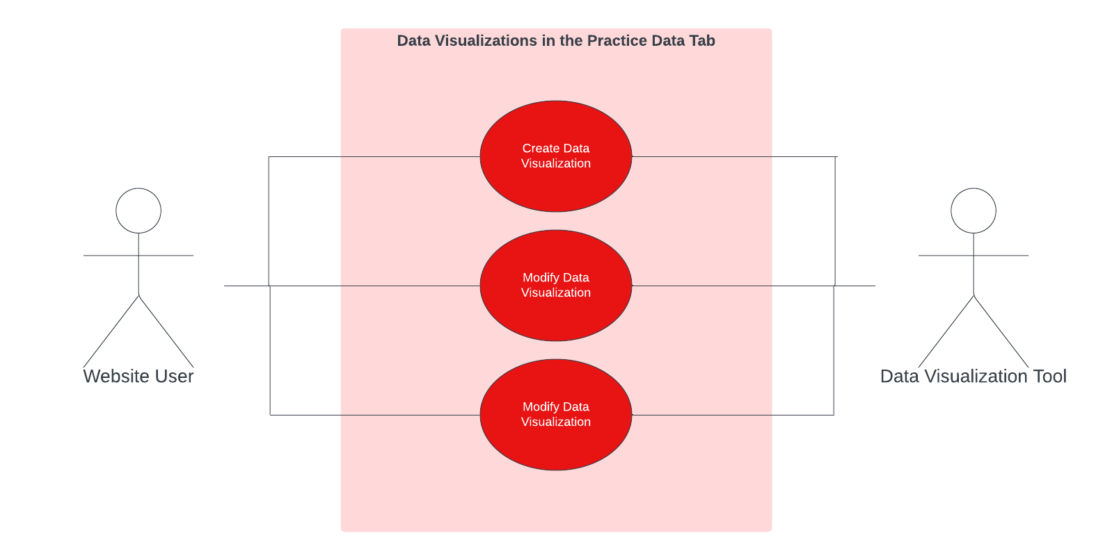

**Use Case Diagram Narrative**

Users can utilize the data visualization tool in the ‘Practice Data’ tab by either creating new data visualizations or modifying or deleting pre-existing ones based on their data needs. This tool exists within the website and will be accessible to all website users via the ‘Practice Data’ tab.

## **Use Case 43 – 45: Comparison Tab**

### **Use Case Description: Use Case 43: Create a Comparison Between Players in the Comparison Tab:**

|  |  |  |
| --- | --- | --- |
| **Use Case Name**: Create a Comparison Between Players in the Comparison Tab | **ID**: 43 | **Importance Level**: Low |
| **Primary Actor**: Website User | | **Use Case Type**: Detail, Essential |
| **Stakeholders and Interests**:   * Website User: create a comparison * Website: where the comparison is created * Player Comparison Tool: creates player comparison | | |
| **Brief Description**: User can create a comparison using the Comparison Tab | | |
| **Trigger**: User clicks on ‘Compare Player’ button  **Type**: External | | |
| **Relationships**:  *Association:* Website User, Player Comparison Tool  *Include:*  *Extend:* Edit a comparison between players in the Comparison Tab, Delete a comparison  between players in the Comparison Tab  *Generalization:* Player Comparison in the Player Comparison Tab | | |
| **Normal Flow of Events:**   1. The website user logs onto database. 2. The website user verifies their identity via two-factor authentication application. 3. The website user chooses ‘Player’ on sidebar to enable the ‘Player Dashboard’. 4. The website user clicks the name of the player he wants to edit. 5. The website user clicks the ‘Compare Player’ tab. 6. Website user creates a comparison. | | |
| **SubFlows:**   * *None Identified* | | |
| **Alternate/Exceptional Flows:**  1a. User is unable to login due to lack of credentials.  2a. User’s authentication is rejected and is unable to access.  3a. User is unable to access ‘Player Dashboard’ due to limited access.  4a. User is unable to access ‘Compare Player’ tab due to limited access.  5a. Entered data parameters are invalid and creation request is rejected. | | |

### **Use Case Description: Use Case 44: Edit a Comparison Between Players in the Comparison Tab:**

|  |  |  |
| --- | --- | --- |
| **Use Case Name**: Edit a Comparison Between Players in the Comparison Tab | **ID**: 44 | **Importance Level**: Low |
| **Primary Actor**: Website User | | **Use Case Type**: Detail, Essential |
| **Stakeholders and Interests**:   * Website User: edits a comparison * Website: where the comparison is edited * Player Comparison Tool: edits player comparison | | |
| **Brief Description**: User can edit a comparison between players | | |
| **Trigger**: User clicks on *Compare Player* button  **Type**: External | | |
| **Relationships**:  *Association:* Website User, Player Comparison Tool  *Include:* Create a comparison between players in the Comparison Tab  *Extend:* Delete a comparison between players in the Comparison Tab  *Generalization:* Player Comparison in the Player Comparison Tab | | |
| **Normal Flow of Events:**   1. The website user logs onto database. 2. The website user verifies their identity via two-factor authentication application. 3. The website user chooses ‘Player’ on sidebar to enable the ‘Player Dashboard’. 4. The website user clicks the name of the player he wants to edit. 5. The website user clicks the ‘Compare Player’ tab. 6. Website user edits a comparison. | | |
| **SubFlows:**   * *None Identified* | | |
| **Alternate/Exceptional Flows:**  1a. User is unable to login due to lack of credentials.  2a. User’s authentication is rejected and is unable to access.  3a. User is unable to access ‘Player Dashboard’ due to limited access.  4a. User is unable to access ‘Compare Player’ tab due to limited access.  5a. Entered data parameters are invalid and creation request is rejected. | | |

### **Use Case Description: Use Case 45: Delete a Comparison Between Players in the Comparison Tab**

|  |  |  |
| --- | --- | --- |
| **Use Case Name**: Delete a Comparison Between Players in the Comparison Tab | **ID**: 45 | **Importance Level**: Low |
| **Primary Actor**: Website User | | **Use Case Type**: Detail, Essential |
| **Stakeholders and Interests**:   * Website User: delete a comparison * Website: where the comparison is deleted * Player Comparison Tool: deletes player comparison | | |
| **Brief Description**: User can delete a comparison between players | | |
| **Trigger**: User clicks on *Compare Player* button  **Type**: External | | |
| **Relationships**:  *Association:* Website User, Player Comparison Tool  *Include:* Create a comparison between players in the Comparison Tab  *Extend:* Edit a comparison between players in the Comparison Tab  *Generalization:* Player Comparison in the Player Comparison Tab | | |
| **Normal Flow of Events:**   1. The website user logs onto database. 2. The website user verifies their identity via two-factor authentication application. 3. The website user chooses ‘Player’ on sidebar to enable the ‘Player Dashboard’. 4. The website user clicks the name of the player he wants to edit. 5. The website user clicks the ‘Compare Player’ tab. 6. Website user deletes a comparison. | | |
| **SubFlows:**   * *None Identified* | | |
| **Alternate/Exceptional Flows:**  1a. User is unable to login due to lack of credentials.  2a. User’s authentication is rejected and is unable to access.  3a. User is unable to access ‘Player Dashboard’ due to limited access.  4a. User is unable to access ‘Compare Player’ tab due to limited access. | | |

### **Use Case 43 – 45: Sequence Diagram**

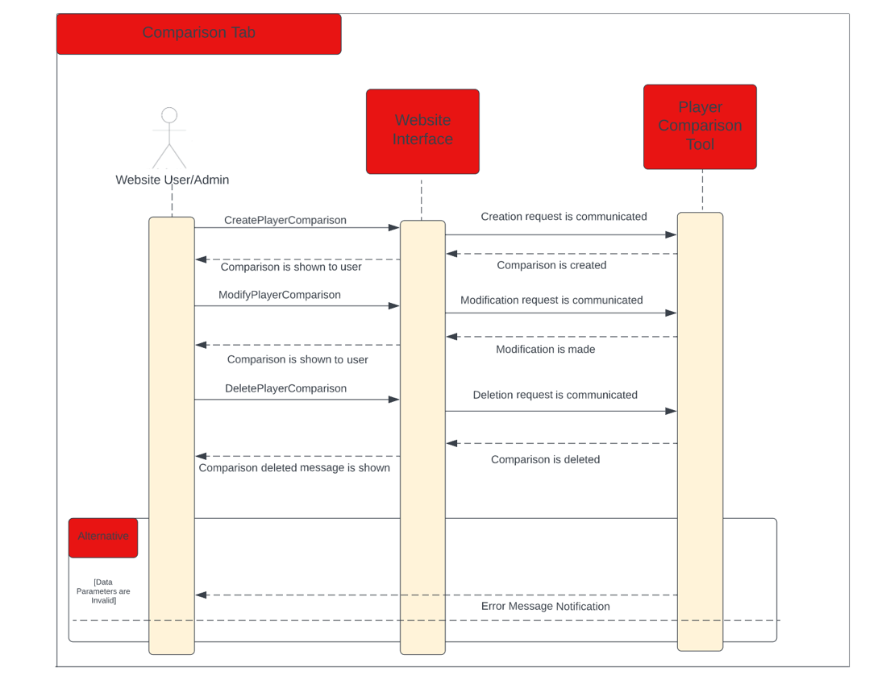

### **Use Case 43 – 45: Use Case Diagram & Narrative**

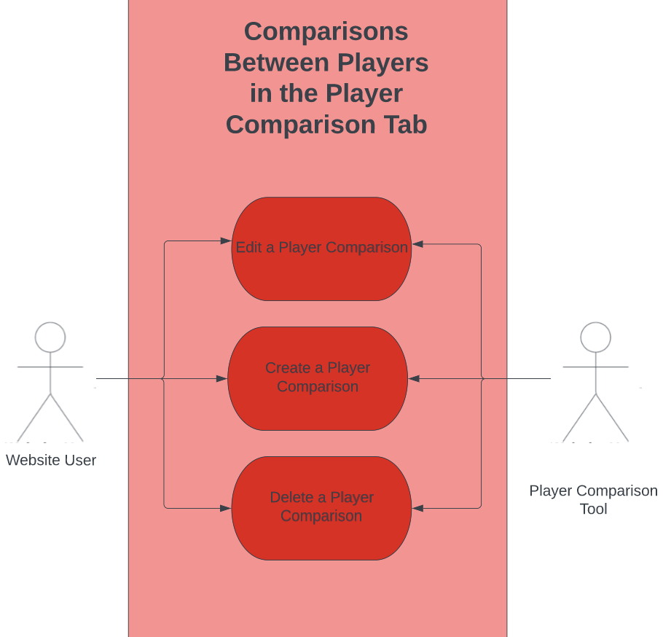

**Use Case Diagram Narrative**

There are three different use cases for our prototype relating to comparisons between players in the Player Comparison Tab. All three of these use cases utilize the Player Comparison Tool. Users can make use of the Player Comparison Tool to create a new player comparison, edit a player comparison that has already been created and needs to be changed, and delete a player comparison that is no longer useful.

## **Use Case 46 – 49: Data Input Tab**

### **Use Case Description: Use Case 46: Import Information into the Data Input Tab**

|  |  |  |
| --- | --- | --- |
| **Use Case Name**: Import information into the Data Input Tab | **ID:** 46 | **Importance Level:** High |
| **Primary Actor:** Coach & Site Users | | **Use Case Type**: Essential |
| **Stakeholders and Interests:**   * Coach: Needs to import player information into the dashboard. * Website: tool used to provide data entry forms. * Database: storage for data | | |
| **Brief Description**: This Use case describes how users will import and export data to and from this website. | | |
| **Trigger**: Coach selects data entry tab  **Type**: External | | |
| **Relationships**:                Association: Coach, CMS, Database                Include: Automatically Import data                Extend: Data Entry, Export Data | | |
| **Normal Flow of Events:**   1. User clicks on data entry tab. 2. User selects data entry Type. 3. User enters data. 4. User can export that data into a CSV file. | | |
| **SubFlows**:   * *None Identified* | | |
| **Alternate/Exceptional Flows:**       4a.  The user’s data is automatically imported from outside sites through an API. | | |

### **Use Case Description: Use Case 47: Export Information into the Data Input Tab:**

|  |  |  |
| --- | --- | --- |
| **Use Case Name:** Export Information from the Data Input Tab | **ID:** 47 | **Importance Level:** Low |
| **Primary Actor:** Coach & Site Users | | **Use Case Type:** Non-Essential |
| **Stakeholders and Interests:**   * Coach: Wants to export data from dashboard. * Website: Tool used to access database. * Database: storage for data | | |
| **Brief Description:** This Use case describes how users will import and export data to and from this website. | | |
| **Trigger:** Coach or Site user selects data entry tab  **Type**: External | | |
| **Relationships**:                Association: Coach, CMS, Database                Include:                Extend: Data Entry, Export Data | | |
| **Normal Flow of Events:**   1. User clicks on data entry tab. 2. User selects export 3. User enters export query 4. Users can export that data into a CSV file. | | |
| **SubFlows:**   * *None Identified* | | |
| **Alternate/Exceptional Flows:**   * Export of data fails. Throws exception with an error code and instructions to contact system administrator. * Data is empty. Most likely due to a query error. Throw query exception and instruct to contact system administrator. | | |

### **Use Case Description: Use Case 48: Administrator Can Manually Edit Data Imported:**

|  |  |  |
| --- | --- | --- |
| **Use Case Name:** Administrator can manually edit data imported | **ID:** 48 | **Importance Level:** High |
| **Primary Actor:** Admin | | **Use Case Type:** Essential |
| **Stakeholders and Interests:**   * Admin: Needs to maintain integrity of data. * Website: tool used to access data. * Database: storage for data | | |
| **Brief Description:** This Use case describes how admins can manage data within the CMS | | |
| **Trigger:** Admin selects data tab within CMS  **Type:** External | | |
| **Relationships**:                Association: Admin, CMS, Database                Include: Automatically Import data                Extend: Data Entry, Export Data | | |
| **Normal Flow of Events:**   1. Admin accesses database 2. Admin edits data within database | | |
| **SubFlows:**   * *Admin accesses previous entry.* * *Admin edit previous entry* * *Admin saves changes.* * *Changes are edited within the data base* * *Changes are display on site.* | | |
| **Alternate/Exceptional Flows:**   * (Potential) – Could add tab in data entry dashboard form direct table editing. | | |

### **Use Case Description: Use Case 49: Administrator Can Automatically Edit Data Imported:**

|  |  |  |
| --- | --- | --- |
| **Use Case Name:** Administrator can automatically import data | **ID:** 49 | **Importance Level:** Low |
| **Primary Actor:** Admin | | **Use Case Type:** Non-Essential |
| **Stakeholders and Interests:**   * Admin: Needs to import data to website. * Coach: Exports from 3rd part tool. * Website: Tool used to allow users to access database. * Database: storage for data | | |
| **Brief Description:** This Use case describes how admins can manage data within the CMS | | |
| **Trigger:** New Data is available  **Type:** External | | |
| **Relationships:**                Association: Coach, CMS, Database                Include: Automatically Import data                Extend: Data Entry, Export Data | | |
| **Normal Flow of Events**   1. Information is tracked within a 3rd party application. 2. BudiBase Rest API checks 3rd party applications for new data. 3. If there is new data, Budibase Imports that data onto the website. 4. Else, nothing changes. | | |
| **SubFlows:**   1. *None Identified* | | |
| **Alternate/Exceptional Flows:**   * API throws exception. Instruct that an administrator will be needed to repair interface**.** | | |

### **Use Case 46 – 49: Sequence Diagram:**

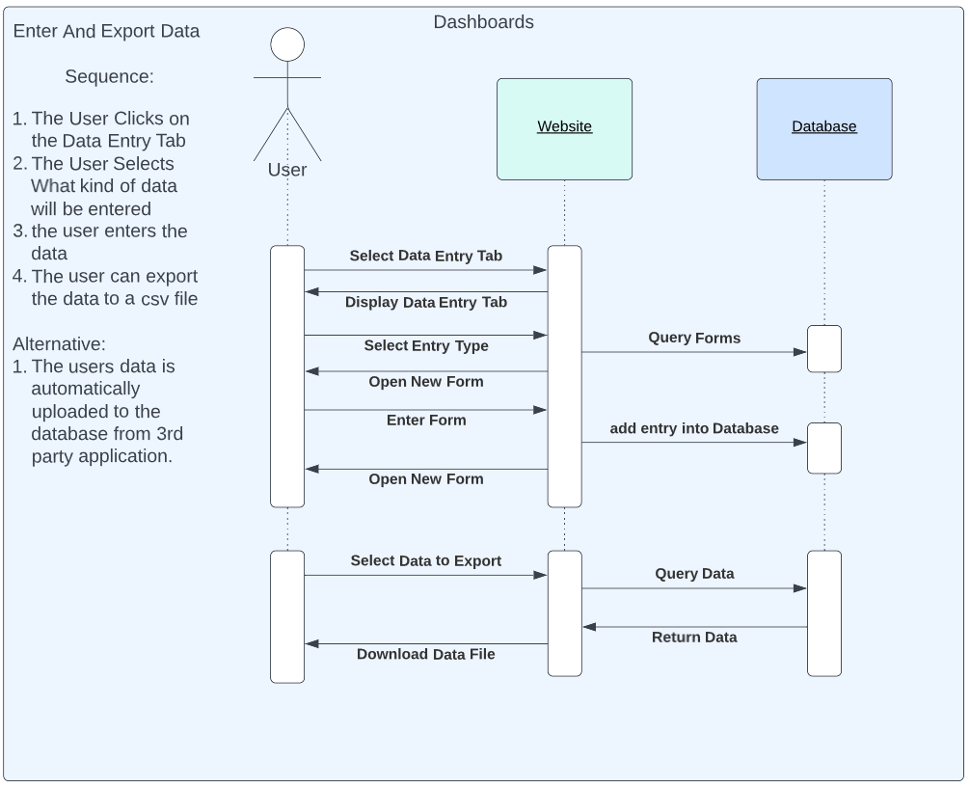

### **Use Case 46 – 49: Use Case Diagram & Narrative**

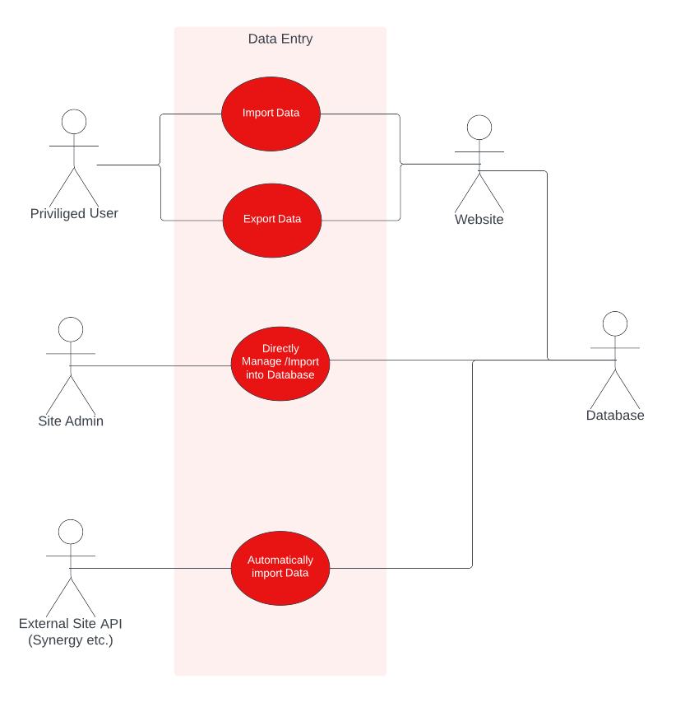

**Use Case Diagram Narrative**

Users with permissions to enter data into the website will be able to do so through the data entry dab and can either import or export information. This process will be handled by the forward-facing web interface then sent to the database to be stored. Administrators will have direct access to this database to troubleshoot and manually import information directly into the database. This process is done through Budibase’s built-in database system. We will also be able to connect external site API’s if the coaches have them. These sites’ information will automatically be uploaded onto the database through the Budibase’s REST API support and will not need to be manually handled. (Where possible, this should be the method of choice.)

# **3. Trace Matrix**

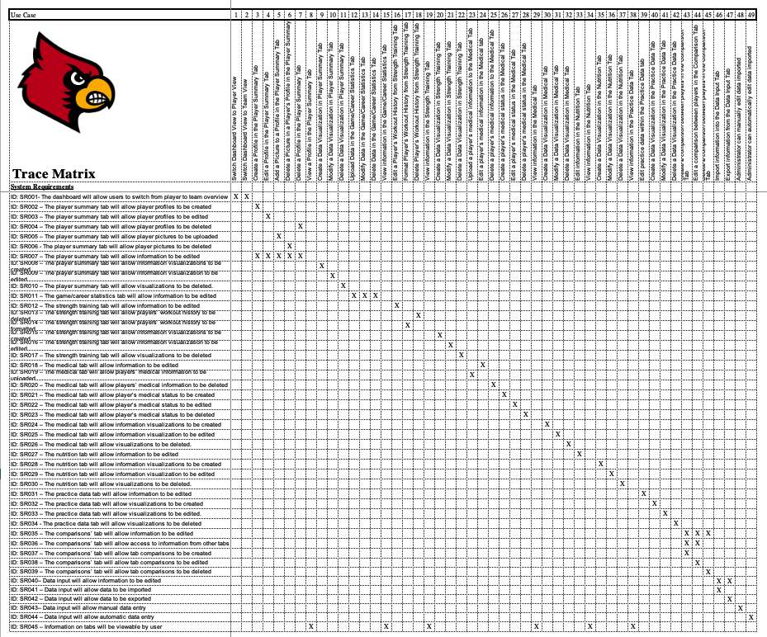

* [**Excel Spreadsheet Link**](https://cardmaillouisville.sharepoint.com/:x:/s/BackyardigansMembers/EQ-6p85ghI1IkLtwFI_q-40BBSsqa3fRZ2mD93Ntr5BLXw?e=o8RRHG)

# **4. Class Diagram & Narrative**

## **Class Diagram Narrative**

Our class diagram outlines all of the major classes necessary for our website. In the red/pink classes related to the webpage operation itself. This contains the parent class page, which all of the other red classes inherit from. From that, the PlayerTab and TeamTab classes are inherited, and they branch out into their own classes for the different kind of tabs that we’re tracking. These all needed to be an individual class because they all have district attributes, those they share are owned by the parent class. The very rightmost class on the webpage section is the Data entry class. When this class is instantiated as an object it will have the ability to create and instantiate forms, which are in green. These forms will be the primary method of manual data entry into the system. The Database elements, highlighted in yellow are elements from the database that data from the forms would be entered. The last section, the blue section, outlines the user classes that would be utilizing the webpage and submitting forms. The Admin and Limited Access User Classes both inherited from the abstract class user. While there are only two classes inheriting from it now, as the lifecycle of the website continues it may be important to expand the amount of concrete user classes so having the abstract parent class was an important addition.

When creating this class diagram, we did run into an issue with our chosen diagram creation software, Lucid chart. Due to the number of classes listed and elements within those classes, we hit the total amount of allowed elements shortly after completing and defining the classes. Because of this, there are some relationships missing from our diagram. Many of these relationships are outlined clearly in our database diagram, especially those related to the database elements. Other than those, all classes that are inheriting from other are denoted by the ‘::’ operator in their name, as all could not receive arrows to represent their inheritance. There should also be some relationship connections between the forms and the database elements. Those are outlined in the Database Diagram as entries.

## **Class Diagram**

* A picture containing diagram

  Description automatically generated[Class Diagram Chart: Full View via Lucid Chart](https://lucid.app/lucidchart/9bc8286c-d868-4179-bf37-da7c131d7987/edit?viewport_loc=-5141%2C-6735%2C11652%2C5810%2C0_0&invitationId=inv_44a5176e-ab25-4f99-b055-aecf8e06131e)

# **5. Database Diagram & Narrative**

## **Database Diagram Narrative**

The database was designed primarily around the player, which is the most important part of the project. The game and practice performance tables store the individual game and practice performances of the players, while the game and practice session tables track games in general. Player notes and all the entry-related tabled near the bottom are storage for forms that would be submitted on the website. The Player Training table takes the entries from below and uses them to create statistics to be put on the strength training tab of the website. The nutrition and medical tabs only have one form so, similarly to the game and practice information, it will be processed to be displayed on the website and does not need an intermediary table.

## **Database Diagram**

# **6. Database Definitions**

## **Player**

|  |  |  |  |  |
| --- | --- | --- | --- | --- |
| Attribute | Definition | Type | Size | Key |
| First_Name | Player’s irst name | String | 255 Bytes (Max) | No |
| Last_Name | Player’s last name | String | 255 Bytes (Max) | No |
| PlayerID | Player’s jersey number | Int | 4 Bytes | Primary |
| Class | Player’s Class (Freshman Sophmore, etc.) | String | 255 Bytes (Max) | No |
| Position | Player’s game position | String | 255 Bytes (Max) | No |
| Height (m.) | Player’s height, in meters | Float | 4 Bytes | No |
| Weight (lbs.) | Player’s weight, in pounds | Float | 4 Bytes | No |
| Avg_Point | Player’s average points in games | Float | 4 Bytes | No |
| Avg_Block | Player’s average blocks in games | Float | 4 Bytes | No |
| Avg_Steal | Player’s average steals in games | Float | 4 Bytes | No |
| 2Point%  (2 Pointer Percentage) | Two point shot hit percentage, in decimal form | Float | 4 Bytes | No |
| 3Point%  (3 Pointer Percentage) | Three point shoot hit percentage in decimal form | Float | 4 Bytes | No |

## **Team**

|  |  |  |  |  |
| --- | --- | --- | --- | --- |
| **Attribute** | **Definition** | **Type** | **Size** | **Key** |
| **Team_Name** | Team name | String | 255 Bytes (Max) | Primary |
| **Location** | Team location | String | 255 Bytes (Max) | No |
| **Coach** | Team Coach | String | 255 Bytes (Max) | No |

## 

## **Game (Game has many Game Performances)**

|  |  |  |  |  |
| --- | --- | --- | --- | --- |
| **Attribute** | **Definition** | **Type** | **Size** | **Key** |
| **Game_ID** | Unique identifier for game | Unsigned long | 4 Bytes | Primary |
| **Home** | Home game | String | 225 Bytes (Max) | No |
| **Away** | Away game | String | 225 Bytes (Max) | No |
| **Date** | Date of game | Date | 3 Bytes | No |
| **Winner** | The name of the winning team | String | 255 Bytes (Max) | No |
| **Score** | Score of the game | String | 4 Bytes | No |
| **Location** | Location of the game | String | 4 Bytes | No |

## **Game Performance**

|  |  |  |  |  |
| --- | --- | --- | --- | --- |
| **Attribute** | **Definition** | **Type** | **Size** | **Key** |
| **Performance_ID** | Unique identifier for game performance | Unsigned long | 4 Bytes | Primary |
| **Player_ID** | Player’s jersey number | Int | 4 Bytes | Foreign |
| **Game_ID** | Unique identifier for game | Unsigned long | 4 Bytes | Foreign |
| **Points** | Player’s number of points in games | Float | 4 Bytes | No |
| **Rebounds** | Player’s number of rebounds in games | Float | 4 Bytes | No |
| **Assists** | Player’s number of assists during games | Float | 4 Bytes | No |
| **Steals** | Player’s number of steals in games | Float | 4 Bytes | No |
| **Blocks** | Player’s number of blocks in games | Float | 4 Bytes | No |
| **2PTM**  **(2 Pointers Made)** | The amount of 2 pointers made, in decimal form | Float | 4 Bytes | No |
| **2PTA**  **(2 Pointers Attempted)** | The amount of 2 pointers attempted | Float | 4 Bytes | No |
| **2PT%**  **(2 Pointer Percentage)** | Two point shot hit percentage, in decimal form | Float | 4 Bytes | No |
| **3PTM**  **(3 Pointers Made)** | The amount of 3 pointers made | Float | 4 Bytes | No |
| **3PTA**  **(3 Pointers Attempted)** | The amount of 3 pointers attempted | Float | 4 Bytes | No |
| **3PT%**  **(3 Pointers Percentage)** | Three pointers hit percentage, in decimal form | Float | 4 Bytes | No |
| **FTM**  **(Free Throws Made)** | The number of free throws made | Float | 4 Bytes | No |
| **FTA**  **(Free Throws Attempted)** | The number of free throws attempted | Float | 4 Bytes | No |
| **FT%**  **(Free Throws Percentage)** | The percentage of free Throw | Float | 4 Bytes | No |
| **TO**  **(Turnover)** | The amount turnovers | Float | 4 Bytes | No |

## **Practice Session: (Has many Practice Performances)**

|  |  |  |  |  |
| --- | --- | --- | --- | --- |
| **Attribute** | **Definition** | **Type** | **Size** | **Key** |
| **Practice_ID** | Unique identifier for practice session | Unsigned long | 4 Bytes | Primary |
| **Date** | Date of a practice session | Date | 3 Bytes | No |

## **Practice Performance**

|  |  |  |  |  |
| --- | --- | --- | --- | --- |
| **Attribute** | **Definition** | **Type** | **Size** | **Key** |
| **Player_ID** | Player Jersey’s Number | Int | 4 Bytes | Foreign |
| **Performance_ID** | Unique identifier for practice performance | Unsigned long | 4 Bytes | Primary |
| **Practice_ID** | Unique identifier for practice | Unsigned long | 4 Bytes | Foreign |
| **Points** | Player’s number of points in a game | Float | 4 Bytes | No |
| **Rebounds** | Player’s number of rebounds in a game | Float | 4 Bytes | No |
| **Assists** | Player’s number of assists during a game | Float | 4 Bytes | No |
| **Steals** | Player’s number of steals in a game | Float | 4 Bytes | No |
| **Blocks** | Player’s number of blocks in a game | Float | 4 Bytes | No |
| **2PTM**  **(2 Pointers Made)** | The amount of 2 pointers made, in decimal form | Float | 4 Bytes | No |
| **2PTA**  **(2 Pointers Attempted)** | The amount of 2 pointers attempted | Float | 4 Bytes | No |
| **2PT%**  **(2 Pointers**  **Percentage)** | Two point shot hit percentage, in decimal form | Float | 4 Bytes | No |
| **3PTM**  **(3 Pointers Made)** | The amount of 3 pointers made | Float | 4 Bytes | No |
| **3PTA**  **(3 Pointers Attempted)** | The amount of 3 pointers attempted | Float | 4 Bytes | No |
| **3PT%**  **(3 Pointers Percentage)** | Three point shoot hit percentage in decimal form | Float | 4 Bytes | No |
| **FTM**  **(Free Throws Made)** | The number of free throws made | Float | 4 Bytes | No |
| **FTA**  **(Free Throws Attempted)** | The number of free throws attempted | Float | 4 Bytes | No |
| **FT%**  **(Free Throws Percentage)** | The percentage of free Throw | Float | 4 Bytes | No |
| **TO**  **(Turnover)** | The amount turnover | Float | 4 Bytes | No |

## **Player Notes**

|  |  |  |  |  |
| --- | --- | --- | --- | --- |
| **Attribute** | **Definition** | **Type** | **Size** | **Key** |
| **Note_ID** | Unique identifier for player notes | Unsigned load | 4 Bytes | Primary |
| **Player_ID** | The player’s jersey number | Int | 4 Bytes | Foreign |
| **Title** | Title of player notes | String | 255 Bytes (Max) | No |
| **Class** | Player’s class (freshman, Sophomore, Etc.) | String | 255 Bytes (Max) | No |
| **Date** | Date of player’s notes added | Date | 3 Bytes | No |
| **Content** | Content of player notes | String | 255 Bytes (Max) | No |

## **Nutrition Entry**

|  |  |  |  |  |
| --- | --- | --- | --- | --- |
| **Attribute** | **Definition** | **Type** | **Size** | **Key** |
| **Entry_ID** | Unique identifier for nutrition entry | Unsigned load | 4 Bytes | Primary |
| **Player_ID** | The player’s jersey number | Int | 4 Bytes | Foreign |
| **Date** | Date of nutrition entry for player | Date | 3 Bytes | No |
| **Calorie Goal** | Player’s calorie goal | Float | 4 Bytes | No |
| **Actual Calories** | Player’s actual calorie count | Float | 4 Bytes | No |

## **Medical Entry**

|  |  |  |  |  |
| --- | --- | --- | --- | --- |
| **Attribute** | **Definition** | **Type** | **Size** | **Key** |
| **Entry_ID** | Unique identifier for medical entry | Unsigned load | 4 Bytes | Primary |
| **Player_ID** | The player’s jersey number | Int | 4 Bytes | Foreign |
| **Date** | Date of medical entry for player | Date | 3 Bytes | No |
| **Player Status** | Player’s medical status during a game | Float | 4 Bytes | No |
| **Recovery Time** | Recovery time of player | Float | 4 Bytes | No |

## **Catapult Entry**

|  |  |  |  |  |
| --- | --- | --- | --- | --- |
| **Attribute** | **Definition** | **Type** | **Size** | **Key** |
| **Entry_ID** | Unique identifier for catapult entry | Unsigned load | 4 Bytes | Primary |
| **Player_ID** | The player’s jersey number | Int | 4 Bytes | Foreign |
| **Period Name** | Period name of Catapult entry | String | 4 Bytes | No |
| **Date** | Date of Catapult entry for player | Date | 3 Bytes | No |
| **Start Date** | Start date of Catapult entry | Date | 3 Bytes | No |
| **End Time** | End date of Catapult entry | Date | 3 Bytes | No |
| **Total Duration** | Time duration of Catapult | Date | 3 Bytes | No |
| **Player Load Band 1 Total Player Load** | Player load band 1 for Catapult | Int | 255 Bytes (Max) | No |
| **Player Load Band 2 Total Player Load** | Player load band 2 for Catapult | Int | 255 Bytes (Max) | No |
| **Player Load Band 3 Total Player Load** | Player load band 3 for Catapult | Int | 255 Bytes (Max) | No |
| **Player Load Band 4 Total Player Load** | Player load band 4 for Catapult | Int | 255 Bytes (Mmx) | No |
| **Player Load Band 5 Total Player Load** | Player load band 5 for Catapult | Int | 255 Bytes (Max) | No |
| **Player Load Band 6 Total Player Load** | Player load band 6 for Catapult | Int | 255 Bytes (Max) | No |
| **Player Load Band 7 Total Player Load** | Player load band 7 for Catapult | Int | 255 Bytes (Max) | No |
| **Player Load Band 8**  **Total Player Load** | Player load band 8 for Catapult | Int | 255 Bytes (Max) | No |

**Force Plate Entry**

|  |  |  |  |  |
| --- | --- | --- | --- | --- |
| **Attribute** | **Definition** | **Type** | **Size** | **Key** |
| **Entry_ID** | Unique identifier for force plate entry | Unsigned load | 4 Bytes | Primary |
| **Player_ID** | The player’s jersey number | Int | 4 Bytes | Foreign |
| **Date** | Date of force plate entry for player | Date | 3 Bytes | No |
| **System Weight (N)** | Player’s weight keyed into the system | Float | 4 Bytes | No |

## **Jump Height Entry**

|  |  |  |  |  |
| --- | --- | --- | --- | --- |
| **Attribute** | **Definition** | **Type** | **Size** | **Key** |
| **Entry_ID** | Unique identifier for jump height entry | Unsigned load | 4 Bytes | Primary |
| **Player_ID** | The player’s jersey number | Int | 4 Bytes | Foreign |
| **Date** | Date of jump height entry for player | Date | 3 Bytes | No |
| **Jump Height (m)** | Player’s average jump height, measured in meters | Float | 4 Bytes | No |

## **Training**

|  |  |  |  |  |
| --- | --- | --- | --- | --- |
| **Attribute** | **Definition** | **Type** | **Size** | **Key** |
| **Player_ID** | The player’s jersey number | Int | 4 Bytes | Primary |
| **Avg Player Height** | Player’s average height | Float | 4 Bytes | No |
| **Min Jump Height** | Player’s minimum jump height | Float | 4 Bytes | No |
| **Max Jump Height** | Player’s maximum jump height | Float | 4 Bytes | No |
| **Avg System Weight** | Player’s average weight | Float | 4 Bytes | No |
| **Min System Weight** | Player’s minimum weight | Float | 4 Bytes | No |
| **Max System Weight** | Player’s maximum weight | Float | 4 Bytes | No |
| **Avg Total Player Load (Catapult)** | Player’s average total load | Float | 4 Bytes | No |

# **7. User Interface Navigation Diagram & Narrative**

## **User Interface Navigation Diagram Narrative**

The following is a Window Navigation Diagram. The diagram entails the basic components of the system. It shows how interactions between the user and the websites, as well as the interactions the website has with itself.

## **User Interface Navigation Diagram**

# **8. Screen Layouts**

## **Data Capture Forms**

### **Edit Profile Form**

This shows the initial design for how the system will react whenever the edit profile link is clicked. The form shows required fields that will make up the details involving a player’s information. If all required fields are entered, the system will update it and be displayed as seen in the finished version

### **Edit Visualizations Form**

This shows the initial design of how the system will respond to clicking edit visual tools form. The form includes the various types of visualizations available, as well as the tab and information to go from. Once all required fields are completed and created, the website will automatically update the tab with the new visuals and data.

### **Medical Entry Form**

This shows the initial design when the edit medical form is clicked. The form includes multiple required fields in regards of everything assessed during a player’s physical. Once all required fields have been filled in, the save button will automatically update the tab with the new information for faculty and player to view.

### **Data Input**

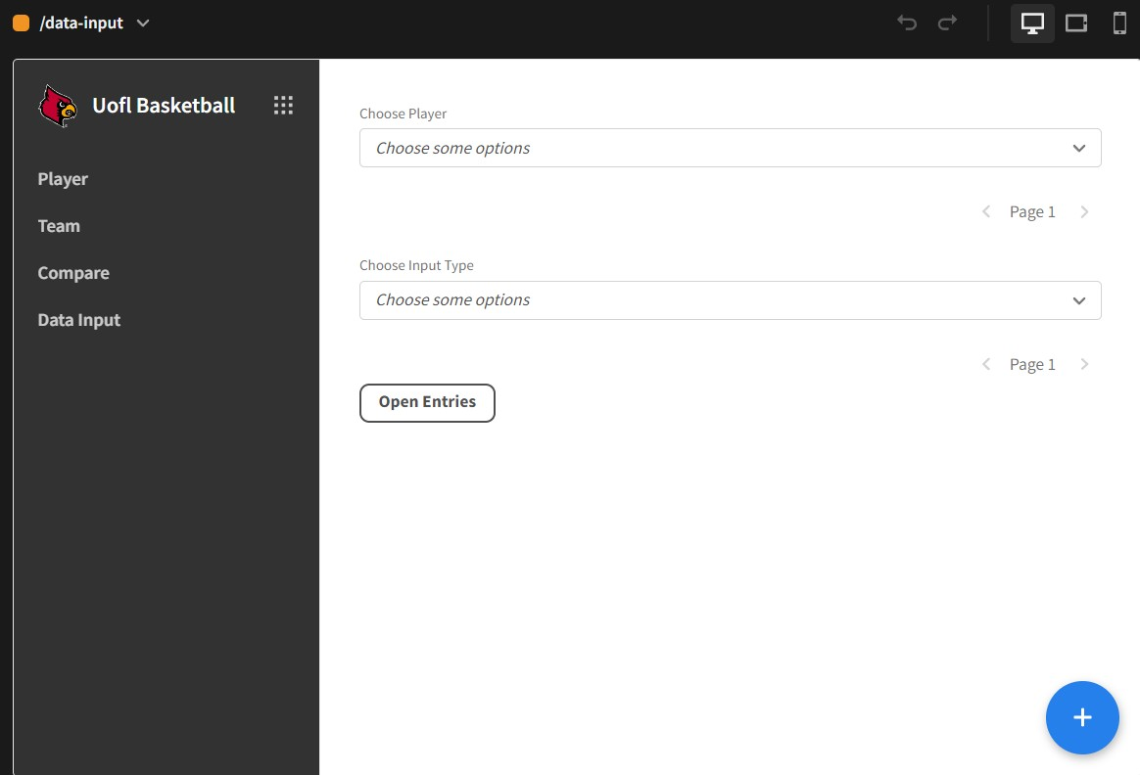

The following image shows the initial design for when a member clicks to input data. When clicked it brings the user to a tab that allows the user to select the player and the type of data needed. Once completed, it will redirect you to one of the forms described previously. Following this, after the form data is completed, the system will automatically update the affected tabs for viewers to view.

## **Data Presentation Forms**

### **Player Summary**

The following entails the result of a finished view of player data being presented. It goes in-depth in various visuals related to a player’s data depending on the data the user wants to use. When edited, it allows a user to select which visuals in tandem with data that can be presented on the tab.

### **Player Medical Tab**

This entails the data representation of a player’s medical tab. It describes a player’s status and allows it to be edited if a player is injured. The website also goes into details of previous health events or injuries during the season.

# **9. Gantt Chart**

* [Excel Spreadsheet Link](Backyardigans%20I5.xlsx)

## **Gantt Chart Narrative**

Gantt Charts are a Team Management tool that provides support for the organization towards a given project. The chart also provides context towards dependencies for connecting objectives in the project. Provided above is a Gantt Chart that details prior Iterations from I3-I5. It lists objectives that have been finished in a chronological order. It has been updated for the Elaboration Specifications to include objectives in regards of use case assignments per team member. It labels the time it takes for each and includes newer objectives such as the Gantt Chart, Physical Architecture Design, and the Design Procedure.

# **10. Physical Architecture Design:**

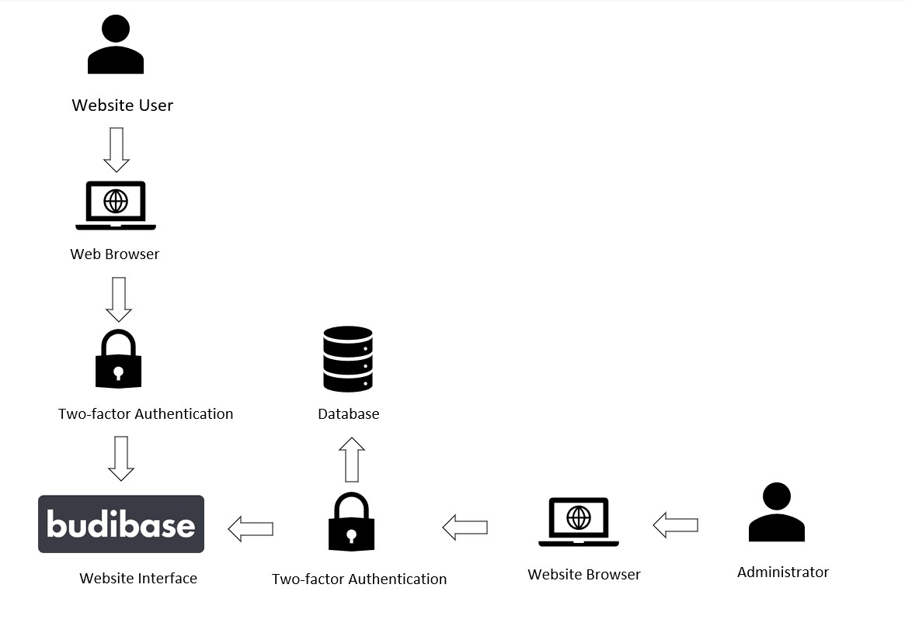

The purpose of this physical architecture design is to show the process which both the Website User and the Administrator use to gain access to the Website Interface. Both actors will begin their process by logging onto a web browser, where they will be asked to verify their identity using a two-factor authentication system. Upon identity verification, the actors will gain access to the Website Interface. The Website User’s process ends here, due to their limited access ability. However, the Administrator can login into the Database and make necessary changes based on their goals

# **11. Design Procedures for Security Concerns & Nonfunctional Requirements:**

There are a number of features in our prototype that address the security concerns within the project. We understand that data security is very important, and our information falling into the wrong hands, or our data being incorrect could have extremely bad consequences and be detrimental to team success and would be a bad look for the organization. The first feature we have to address these concerns is Two Factor Authentication. In order to log into our website, you will need to confirm your identity by using Two Factor Authentication and using the code it sends to your U of L email to log in. This is to ensure that only people who should be having access to our data gain access, meaning our data will be safe and secure. The other notable feature we have is the permission levels that we will give to certain members of the staff. Users with the administrator role will be the only ones who are able to edit and delete data. This is so we can be certain that all data is correct and accurate, because if our data becomes inaccurate that will cause us to draw incorrect conclusions which will hurt the team. This is how we will address the security concerns for our project.

# **12. Elaboration Phase Prototypes**

## **Use Case 1 – 2: Switch Dashboard Views**

### **Player Select Dashboard**

### **Team Stats Dashboard**

## **Use Case 3 - 8: Profile Tool in Player Summary Tab**

### **Edit Profile in Player Summary Tab**

## **Use Case 9 – 11: Data Visualization Tool in the Player Summary Tab**

**

**

**

### **Modify View of the Data Visualization Tool**

**

## **Use Case 12 – 15: Game/Career Statistics Tab**

### **Upload/View data on Game/Career Statistics Tab**

## **Use Case 16 – 19: Strength Training Tab**

### **View information on Strength Training Tab**

**Edit a player’s workout history on Strength Training Tab**

## **Use Case 20 - 22: Data Visualizations in the Strength Training Tab**

**

### **Modify View of the Data Visualization Tool**

### **Delete View of the Data Visualization Tool**

## **Use Case 23 – 29: Medical Tab & Medical Status**

### **Create medical records on Medical Tab**

### **Update medical records on Medical Tab**

### **Delete medical records on Medical Tab**

### **View medical records on Medical Tab**

**Use Case 31 – 32: Data Visualizations in the Medical Tab**

**

### **Modify View of the Data Visualization Tool**

### **Delete View of the Data Visualization Tool**

## **Use Case 33 – 34: Nutrition Tab**

### **Edit information in Nutrition Tab**

**View/Edit information in Nutrition Tab**

## **Use Case 35 – 36: Data Visualizations in Nutrition Tab**

**Full-Screen Create View of the Data Visualization Tool**

### **Modify View of the Data Visualization Tool**

**Delete View of the Data Visualization Tool**

## **Use Case 38 – 39: Practice Tab**

### **Practice Tab Data**

## **Use Case 40 – 42: Data Visualizations in the Practice Tab**

**Full-Screen Create View of the Data Visualization Tool**

### **Modify View of the Data Visualization Tool**

**Delete View of the Data Visualization Tool**

## **Use Case 43 - 45: Comparison Tab**

## **Use Case 46 - 49: Data Import & Export**

### **Website Interface for Submitting Data**

### **Database Manager and REST API Integration**

